Enhanced microemulsion formation in lipid-based drug delivery systems by combining mono-esters of medium-chain fatty acids with di- or tri-esters

Darshil P. Patelª, Ping Li^{b}, Abu T. M. Serajuddin^{a*}
ªCollege of Pharmacy and Allied Health Professions, St. John’s University, 8000 Utopia Parkway, Queens, NY 11439, USA
^{b}Novartis Pharmaceuticals Corp., 1 Health Plaza, East Hanover, NJ 07936, USA

*Corresponding author: Abu T. M. Serajuddin, Tel: 718-990-7822, Fax: 718-990-1877, E-mail: serajuda@stjohns.edu

ABSTRACT

To develop strategies for selecting appropriate lipids from mono-, di- and tri-esters of medium-chain fatty acids for the development of lipid-based drug delivery systems, ternary phase diagrams of propylene glycol (PG) monocaprylate (Capryol 90®; HLB~7), PG dicaprylocaprate (Labrafac PG®; HLB~2) and glycerol tricaprylocaprate (Labrafac Lipophile WL1349®; HLB~2) were determined in combination with a common surfactant, PEG-35 castor oil (Cremophor EL®; HLB~13), and water. Particle size and viscosity in different regions of phase diagrams were measured, solubility of a model drug, danazol, in different lipid-surfactant mixtures was determined, and dispersion testing by diluting selected preconcentrates with 250 mL 0.01NHCl was performed. Further, phase diagrams were constructed using binary mixtures of lipids (monoester with diester, or monoester with triester) in place of single lipids. The phase diagrams of PG dicaprylocaprate and glycerol tricaprylocaprate were similar, while it was distinctly different for PG monocaprylate. The microemulsion regions in phase diagrams were rather limited for individual lipids, and additionally, the di- and tri- esters showed pronounced gel regions in the phase diagrams, which could influence drug release from preconcentrates. The mixing of PG monocaprylate (monoester) with PG dicaprylocaprate (diester) or glycerol tricaprylocaprate (triester) had dramatic effects on the performance of lipids as evidenced from the greatly reduced gel phases, much larger microemulsion regions, faster dispersion of the preconcentrates in an aqueous medium, and smaller particle size of the microemulsions formed.

KEY WORDS: Lipid-based drug delivery, SEDDS, medium chain lipid, propylene glycol ester, triglyceride, phase diagram, drug solubility, dispersion test

Introduction

Lipid-based drug delivery systems have extensively been studied for their application in increasing the bioavailability of poorly water-soluble drugs (1-9). In addition to enhanced bioavailability, the lipid-based oral delivery is known to reduce food effect as it presents the drug to the gastrointestinal system in a solubilized state (10-12). It also helps in lowering first-pass metabolism of certain drugs, although to a very limited extent, by channeling them to the lymphatic drug transport system (8).

Lipid-based formulations are usually developed as preconcentrates consisting of lipid, surfactant, and, if necessary, co-surfactant and/or co-solvent. They form emulsions or microemulsions upon dilution with aqueous media in the gastrointestinal tract. Depending on the size of the lipid globules formed in aqueous media, the preconcentrates are usually called self-emulsifying drug delivery system (SEDDS) or self-microemulsifying drug delivery system (SMEDDS). There has been a long controversy over what constitutes a microemulsion and whether it is indeed an emulsion or a micelle (13). It is now generally recognized as the thermodynamically stable micellar or swollen micellar system of lipid, surfactant and water (14). In pharmaceutical application, it is a thermodynamically stable clear or translucent dispersion of lipids with particles usually less than 200 nm that is formed spontaneously upon addition of water to SMEDDS containing lipid/surfactant or lipid/surfactant/co-surfactant mixtures (15, 16). Therefore, the SMEDDS is also referred to as microemulsion preconcentrate (9). The term ‘micro’ in SMEDDS refers to ‘small’ particles and the actual size of particles formed is indeed in the lower nanometer range (usually <250 nm). In contrast, SEDDS produce opaque and milky emulsions upon dilution with aqueous media with particle size of lipid globules >250 nm that may further grow or phase separate as the dispersion is thermodynamically unstable. To develop a rational basis of differentiating various lipid-based formulations, Pouton (17, 18) introduced a lipid formulation classification system (LFCS) that categorizes various formulations in four classes, namely, Type I, Type II, Type III and Type IV. The classification is based on compositions of formulations as well as potential effects of dilution with aqueous media on dispersion of formulations, digestion of lipids and possible precipitation of drugs. Among them, Type III formulations form microemulsions of lipid-surfactant mixtures with particle size in the range of 50 to 250 nm. According to the LFCS, it is preferable that the lipid-based systems for bioavailability enhancement of poorly water-soluble drugs are developed as Type III formulations since the drugs may be absorbed from microemulsions without the digestion of lipids and/or surfactants present and thus the drugs remain in a solubilized state until their absorption (17, 18). Pouton (18) further divided Type III formulations into IIIA and IIIB having lipid contents of 40-80 and <20 %w/w, respectively, where Type IIIA may have advantages over Type IIIB as more lipid is available to solubilize drug in the preconcentrate as well as in the microemulsion formed after dilution with aqueous media.

Many lipids are available for the development of lipid-based systems (19-21). They include vegetable oils, glycerides and partial glycerides of medium chain and unsaturated long chain fatty acids, and polyalcohol (e.g., propylene glycol) esters of medium chain fatty acids. Despite the availability of many different lipids as well as the abundance of poorly water-soluble drugs in the discovery and the development pipeline in the pharmaceutical industry that could benefit from the use of lipids in their formulations, the number of lipid-based drug products for poorly water-soluble drugs has been limited. Mullertz et al. (21) reported that, as of 2010, there were only five Type III lipid-based formulations for marketed drugs available (ciprofloxacin, cyclosporine A, lopinavir, ritonavir and tipranavir). The authors attributed the situation to the lack of adequate knowledge and understanding of various issues involved in the development of such delivery systems. For example, the physicochemical properties of lipids must be understood clearly for their use in the development of Type III formulations. The lipids differ based on their hydrophilic-lipophilic properties. Certain lipids, especially the triglycerides, are completely lipophilic with HLB values of zero or close to zero because of the absence of any hydrophilic moiety. On the other hand, among the lipids containing hydrophilic moieties, there can be difference in the degree of hydrophilicity depending on their chemical structure (22, 23). For example, the mono- and di-glycerides of long and medium chain fatty acids have hydrophilic properties due to the presence of free -OH groups and their hydrophilic-lipophilic balance (HLB) depends on whether one or two -OH groups are free and the rest are esterified. Complicating the situation, most of the commercially available lipids are not available as pure species. Rather, they are mixtures of lipids with differing hydrophilic-lipophilic properties and differing fatty acid chain lengths. No systematic study has been reported in the literature on how the hydrophilic-lipophilic properties of lipids influence the development of Type III lipid-based formulations. The impact of combining two lipids with different degrees of hydrophilic-lipophilic properties in a formulation is also not fully understood.

We have undertaken comprehensive studies in our laboratory to develop a rational approach of selecting lipids for their suitability in the development of LFCS Type III formulations and, in particular, their ability to form microemulsions and emulsions in presence of surfactant and water (16, 24). In a previous study (24), we compared effects of fatty acid chain lengths of medium chain lipids (C₈ versus C₁₂) on their performance in lipid-based drug delivery systems. PG monoesters and PG diesters with C₈ to C₁₂ fatty acids were used. The focus of the present study was to determine the effect of the degree of esterification of lipids on their performance in lipid-based drug delivery systems by taking PG esters of lower chain length (C₈ or mixtures of C₈ and C₁₀) only. We recently reported the effect of the degree of esterification of glycerides on lipid-based drug delivery systems (16). It was, therefore, of interest to determine whether PG esters would perform in a similar manner. PG monocaprylate (C₈-fatty acid) and PG dicaprylocaprate (mixture of C₈ and C₁₀-fatty acids) were, respectively, used as mono- and di-esters, and, since PG cannot form a triester, glycerol tricaprylocaprate (mixture C₈ and C₁₀-fatty acids) was used as the tri-ester for comparison. Ternary phase diagrams of lipid-surfactant-water mixtures were determined for individual lipids and combinations of lipids using a common surfactant, PEG 35 castor oil. The various phases in different phase diagrams were characterized by particle size analysis and viscosity measurement. The solubility of a poorly water-soluble model drug, danazol, was studied in different lipids and lipid-surfactant mixtures. In addition, drug solutions in different lipid-surfactant mixtures were evaluated for their ability to emulsify or disperse in aqueous media. Another ancillary aspect of the present study was to compare PG esters from two suppliers. As mentioned earlier, most of the commercially available lipids are mixtures of more than one species of esters, and, therefore, there could be differences from materials obtained from two manufacturers. The PG esters used in the present study was obtained from a different manufacturer than those used in a previous study (24); it was, therefore, of interest to determine whether the materials from the two suppliers would exhibit similar phase diagrams.

Materials and Methods

Materials

PG monocaprylate (Capryol 90), PG dicaprylocaprate (Labrafac PG) and glycerol tricaprylocaprate (Labrafac Lyophile WL1349) were received as donation from Gattefosse Corp, Paramus, New Jersey, USA. PEG-35 castor oil (Cremophor EL) was donated by BASF, Tarrytown, New York, USA. The pharmaceutical grade danazol was received as a gift from a pharmaceutical company in the USA. The lipids are not commercially available in pure forms; they are usually mixtures of more than one lipids with different chain lengths and different degree of esterification. PG monocaprylate contained >90% monoester of propylene glycol with caprylic acid, while PG dicaprylocaprate was a mixture of PG dicaprylate (50 to 80%) and PG dicaprate (20 to 40%). Glycerol tricaprylocaprate was a mixture of the triglycerides of caprylic acid (50 to 80%) and capric acid (20 to 50%). Structures of the major components of the three lipids used are shown in Fig. 1 on the right-hand sides of their respective phase diagrams. To avoid any possible discrepancy due to any batch-to-batch variability of the lipids and the surfactant, the same batches of materials were used throughout the the study.

Methods

Construction of phase diagrams

Lipid-surfactant-water phase diagrams were constructed for PG monocaprylate, PG dicaprylocaprate and glycerol tricaprylocaprate individually as well as for combinations of PG monocaprylate with PG dicaprylocaprate or glycerol tricaprylocaprate at 1:3 and 1:1 ratios using a method described earlier (16). Briefly, the lipid (or the combination of lipids) was mixed with the surfactant in 100-mL volumetric flasks at ratios of 9:1, 8:2, 7:3, 6:4, 1:1, 4:6, 3:7, 2:8, 1:9 w/w to prepare a total of 4 g of each mixture. A fixed-speed vortex mixer (Henry Tromner LLC, Thorofare, NJ, USA) was used to mix the lipid and the surfactant uniformly. Distilled water was added to lipid-surfactant mixtures in 5% w/w increments. The concentration of water represented the percentage in the total mixture, that is, in the total amount of lipid, surfactant and water. Therefore, as the combined weight of lipid and surfactant was kept constant at 4 g, the weight of water added increased with the increase in concentration of water in the mixture. For example, 0.21 g of water was necessary for the initial 5% water (increase from 0 to 5% w/w) so that the added water was 5% w/w of the total weight of 4.21 g, while the addition 0.889 g of water was necessary to raise concentration of water from 50 to 55% w/w and thereby decrease the concentration of lipid plus surfactant to 45% w/w (the amount of added water increased from 4 g to 4.889 g, making the total weight 8.889 g). After each addition of water, the mixture was shaken on a wrist action shaker (Burrell Scientific, Pittsburgh, Pennsylvania, USA) by immersing the flasks in a water bath maintained at 25˚C. Any phase change with each increment of water was observed visually. Based on the results of preliminary experiments, the clear liquid or turbid liquid mixtures were shaken for 15 min and mixtures with gel-like consistency were shaken for at least 40 min for equilibration during construction of the phase diagrams.

Particle size analysis

Lipid-surfactant-water mixtures belonging to water-rich regions of the phase diagrams (70% w/w or more water) were analyzed for particle size of lipid globules formed. Mixtures for particle size analysis were prepared separately from those prepared earlier for the purpose of constructing the phase diagrams. However, the method of preparation of the mixtures for both the construction of phase diagrams and the analysis of particle size was the same. Approximately 2-3 mL of the prepared mixture was transferred to a disposable cuvette (Beckman Coulter, Brea, California, USA) and the particle size was then determined with Delsa Nano C (Beckman Coulter) particle analyzer. After particle size analysis, the sample was put back into the flask and additional water was added to each mixture to increase water content consecutively to 80%, 90% and 99% w/w, and the particle size was determined after each dilution. The last dilution (99% w/w) was made in a 500-mL beaker as the total volume of liquid was 400 mL.

Determination of apparent viscosity

The apparent viscosity was determined for gels formed from the dilution of three lipid-surfactant ratios, namely, 30:70, 50:50 and 70:30 w/w, to water contents of 20%, 30%, 40%, 50% and 60% w/w (the apparent viscosity was not measured for any of the mixtures that did not form gel). For each measurement of viscosity, a fresh sample of gel was prepared according to the same procedure as that used for construction of the phase diagrams. Approximately 0.5 mL of the gel was transferred to the cup of the viscometer and the viscosity was measured with Brookfield RVDV III Ultra CP viscometer (Brookfield, Middleboro, Massachusetts, USA) using CPE-52 cone at 150 RPM.

Determination of drug solubility

Solubility of danazol in the surfactant (Cremophor EL), individual lipids and lipid-lipid and lipid-surfactant mixtures was determined by shaking excess of danazol with each solvent (approx. 10 mL each) in 25-mL volumetric flasks for 24 h at 25°C in a water bath using a wrist action shaker (Burrell Scientific) at its highest speed. Since the shaker provided high agitation, the preliminary experiments demonstrated that the equilibrium of solution was reached in about 8 h and there was no further change in concentration when the shaking was continued for 24 h. The equilibrated suspensions were filtered through 0.45-μm pore size polypropylene filters. The first 2-3 mL of filtrate was discarded each time to avoid any drug loss due to possible adsorption onto the filter. Appropriate quantities of filtered aliquots were diluted with methanol, and UV absorbance was measured at 286 nm by using a UV-visible Spectrophotometer (Beckman DU 650i, Beckman Coulter, Brea, California, USA). Appropriately diluted surfactant or lipid-surfactant mixtures (without drug) in methanol served as blanks for UV analysis.

Dispersion test

Dispersion tests were conducted using 250 mL of 0.01N HCL (pH ~ 2) as dispersion medium in a USP dissolution apparatus II (Distek Inc., North Brunswick, New Jersey, USA) at 50 RPM and 37˚C. Dispersion testing was performed for the preconcentrates with 15 mg of danazol dissolved per g of 1:1 mixture of surfactant and lipid (individual lipids or mixtures of them). One gram each of the preconcentrate and the control (containing the same amount of lipid-surfactant mixture but no dissolved drug) was delivered to the bottom of each dissolution vessel using a Pasteur pipette (exact weight determined by weighing pipette before and after delivery of material), and dispersion/emulsification time, when the preconcentrate mixed uniformly with the medium, was noted visually. A 3-mL aliquot was collected at 5, 10, 15, 30, 60 and 120 min and analyzed for particle size and danazol concentration. The danazol concentration was determined using the UV spectrophotometric procedure mentioned earlier. Aliquots were filtered through 0.45 µm filters and diluted with methanol before measuring the UV absorbance. Selected samples were also analyzed without filtration through 0.45 µm filter to determine the effect of filtration on drug concentration. After each collection of aliquot, 3 mL of fresh 0.01N HCL was added to the dissolution vessel to maintain the volume constant at 250 mL.

Results and Discussion
.

Phase diagrams for the individual lipids

Figure 1 gives comparative phase diagrams of the three lipids used. Each phase diagram was constructed from the results obtained by mixing the lipid with the surfactant, Cremophor EL, at different ratios, as indicated on the right side of each diagram, and then adding water. Distilled water was used as the aqueous phase although it is recognized that the lipid-surfactant mixtures are diluted with gastrointestinal fluids upon oral administration as preconcentrates. Since lipids and the surfactant used are non-ionic, preliminary studies showed that a change in pH or the addition of electrolytes at low concentrations did not have a significant impact on phase diagrams produced. The phase diagram of PG monocaprylate in Fig. 1a shows that when water was added to its mixture with surfactant, either clear liquid or milky emulsion was formed. The particle size analysis for different mixtures with water contents from 70 to 90 %w/w demonstrated that the difference between the clear liquid and emulsion regions was the particle size of lipid globules present. The particle size within the clear region was <200 nm, while the particle size within the emulsion region was higher (Table 1). Because of the irregular existence of clear and emulsion regions in Fig. 1a, the phase diagram was constructed twice to ensure reproducibility. Both phase diagrams were found to be identical. Indeed, partial phase diagrams with 70 to 99% w/w water content were constructed twice more during particle size determination, and in all cases the results were similar. This phase diagram in Fig. 1a is also essentially similar to one reported earlier where PG monocaprylate from a different manufacturer was used (24). Although irregular in appearance, the phase diagram was thus found to be highly reproducible. It is apparent from Fig. 1a that water-in-oil (w/o) microemulsions or emulsions were probably first formed when water was added to lipid-surfactant mixtures, which then turned into oil-in-water (o/w) microemulsion or emulsion after dilution to high water content. However, the microemulsion region at high water content was rather limited; only the 10:90-mixture of PG monocaprylate and Cremophor EL gave clear liquid upon dilution to 99% w/w water, i.e, 1 to 100 dilution of preconcentrate with water.

The phase diagrams of Figs. 1b and 1c represent ternary phase diagrams for PG dicaprylocaprate and glycerol tricaprylocaprate, respectively, in presence of Cremophor EL and water. The two phase diagrams are essentially similar. At low water concentrations, the lipid-surfactant mixtures were clear liquids that were apparently w/o microemulsions. As the concentration of water increased, the clear liquids turned into gels, which, upon further addition of water, produced either o/w microemulsion (clear or translucent liquid) or o/w emulsion (turbid liquid) regions. In Fig. 1b, the formation of gel occurred with the addition of ~30% w/w of water at 10:90, 20:80, and 30:70 lipid-surfactant ratios, ~20% w/w of water at 40:60 and 50:50 lipid-surfactant ratios and 10% w/w water at 10:90 and 70:30. In Fig. 1c, the clear w/o microemulsion region appears to be slightly smaller. Between lipid-to-surfactant ratios of 10:90 and 70:30, the gel formed was clear, while at lipid-to-surfactant ratios of 80:20 and 90:10, it was turbid.

It was confirmed by particle size analysis that the clear liquid at high water content represents o/w microemulsion with particle sizes <200 nm, and the o/w emulsions formed had particle sizes >200 nm (Table 1). It may be observed from individual values of particle sizes given in Table 1 in parentheses that the reproducibility of the data was high when microemulsions with particle sizes <200 nm were formed; in case of emulsions with higher particle sizes, especially for the 90:10 lipid-to-surfactant ratio, a larger variability in particle size, even as much as 4 to 5-fold, was observed. This was expected because the microemulsion represents thermodynamically equilibrium systems (14), while the emulsions are nonequilibrium systems where particle sizes of lipid globules may differ depending experimental conditions and time. Although the phase diagrams were constructed by visual observation and the particle size analysis was conducted by preparing fresh samples of appropriate lipid-surfactant-water ratios, there was a good agreement between visual observations and experimental data as the clear or translucent regions had particle sizes of ~200 nm and less.

Table 1 Average particle diameters (nm) of emulsions and microemulsions formed upon dilution of mixtures the individual lipids and the surfactant with water in the range of 70 to 99% w/w. Each value depicts the average of two determinations.
Lipid used and % water |  | Lipid/Surfactant ratio (w/w)
 |  | 90:10 |  | 70:30 |  |  | 50:50 | 30:70 |  | 10:90
PG monocaprylate
70 | 2632  (1014,4250) |  | 706  (860,553) |  |  | 2276  (2476,2077) |  |  | 2562  (2315,2809) |  | 49  (51,47)
80 | 1159  (706,1612) |  | 411  (487,336) |  |  | 768  (1012,525) |  |  | 1300  (1359,1242) |  | 13  (14,13)
90 | 763  (438,1088) |  | 272  (319,226) |  |  | 85  (128,43) |  |  | 370  (368,372) |  | 12  (12,12)
99 | 1354  (389,2319) |  | 198  (228,168) |  |  | 60  (56,64) |  |  | 151  (151,152) |  | 14  (14,14)
PG dicaprylocaprate
70 | 610  (506,714) |  |  | 572  (622,523) |  |  | 451  (418,484) | 50  (37,63) |  | 45  (40,50)
80 | 494  (354.634) |  |  | 365  (448,282) |  |  | 172  (192,153) | 46  (40.53) |  | 22  (28,16)
90 | 733  (494,972) |  |  | 289  (266,313) |  |  | 124  (117,131) | 36  (30,43) |  | 16  (16,17)
99 | 2192  (1092,3292) |  |  | 220  (232,208) |  |  | 125  (87,65) | 37  (49,26) |  | 16  (17.16)
Glycerol tricaprylocaprate
70 | 1233  (564,1902) |  |  |  | 1002  (465,1539) |  | 374  (429,319) | 40  (35,45) |  | 35  (32,38)
80 | 860  (558,1162) |  |  |  | 521  (565,478) |  | 170  (199,141) | 35  (22,48) |  | 23  (18,28)
90 | 1099  (878,1320) |  |  |  | 454  (377,532) |  | 103  (117,89) | 60  (32.89) |  | 22  (17,28)
99 | 4497  (3105,5889) |  |  |  | 320  (311,329) |  | 82  (75,89) | 65  (31,99) |  | 17  (17,18)
________________________________________________________________________________________________________________________

PG monocaprylate, PG dicaprylocaprate and glycerol tricaprylocaprate have certain similarities in that all of them are esters of propane polyols with medium-chain fatty acids of C₈ and C₁₀ chain length. However, their dissimilarities are also distinct. PG monocaprylate is a monoester with one free –OH group, and, therefore, it is a relatively more hydrophilic lipid, with a HLB value of 7, as compared to the other two lipids used. Although PG dicaprylocaprate and glycerol tricaprylocaprate are, respectively, di- and tri-esters of fatty acids, they do not have any free –OH group and thus both of them are either practically lipophilic or only very slightly hydrophilic (HLB~2). The difference in the phase diagram of PG monocaprylate as compared to the the other two and the similarity in phase diagrams of PG dicrylocaprate and glycerol tricaprylocaprate suggest that the hydrophilic-lipoophilic properties of the lipids (as indicated by the HLB values), and not the degree of esterification, was the determining factor for the nature of the phase diagrams produced by the three lipids used in the present study.

Phase diagrams with mixtures of lipids

Pseudoternary phase diagrams were constructed using mixtures of two lipids instead of individual lipids (the term pseudoternary is used since the lipid phase consists of mixtures of two lipids instead of only one). There were two primary reasons for investigating the effects of lipid mixtures on the appearance of phase diagrams. First, the medium chain lipids, such as mono- and di-fatty acid esters of propylene glycol, are not commercially available in pure forms; rather they are available as mixtures with one component being the predominant one. It was, therefore, of interest to determine how a change in the mixing ratio of the lipids would influence phase diagrams. Second, as shown in Fig. 1, the dilution of lipid-surfactant mixtures with water produced compartively small regions o/w microemulsions with the monoester (Fig. 1a), and for the diester (Fig. 1b) and the triglyceride (Fig. 1c), the o/w microemulsions were formed only when the percentage of lipid in the lipid-surfactant mixtures was low (~40% and lower). It was observed in a previous study that mixing a monoglyceride with di- or triglyceride increased the size of microemulsion regions (16). Therefore, it was also of interest to determine whether mixing the two PG esters or the PG monoester with the triglyceride would provide larger o/w microemulsion regions during formulation development. This would then lead to LFCS IIIA formulations with higher lipid contents.

Pseudoternary phase diagrams of mixed lipids were constructed combining PG monocaprylate with PG dicaprylocaprate or glycerol tricaprylocaprate (Fig. 2). Preliminary studies indicated that combining PG dicaprylocaprate with glycerol tricaprylocaprate did not have any major influence on the nature of phase diagrams as compared to those with individual lipids. This was expected as both of them had similar polarities. Therefore, mixtures of a diester with a triester were not used. Fig. 2a and 2b represent pseudoternary phase diagrams of, respectively, 1:3 and 1:1 mixtures of PG monocaprylate (monoester) with PG dicaprylocaprate (diester), while Fig. 2c and 2d show the effect of mixing PG monocaprylate (monoester) with glycerol tricaprylocaprate (triester) at, respectively, 1:3 and 1:1 ratios. Effects of combining the PG monocaprylate with PG dicaprylocaprate or glycerol tricaprylocaprate at 1:3 ratios were essentially similar. In contrast to the phase diagrams obtained for the individual di- and tri-ester lipids in Figs. 1b and 1c, the combination of one part of monoglyceride with three parts of di- or tri-esters in Fig. 2a and 2c, respectively, made the w/o microemulsion regions larger (up to 20-25% water content), decreased both the gel phase and the emulsion region, and expanded the o/w microemulsion regions to higher lipid contents. A more dramatic effect was observed when the PG monoester was mixed with the PG diester or the triglyceride at 1:1 ratios (Fig. 2b and 2d, respectively), where the clear liquid microemulsion regions greatly increased, the emulsion regions were further decreased, and the gel phases were practically eliminated.

The results of particle size analysis with 70% w/w and higher concentrations of selected combinations of mixed lipids with the surfactant are given in Table 2, which demonstrate that o/w microemulsions were obtained at mixed lipids to surfactant ratios between 70:30 and 10:90. Thus, LFCS IIIA formulations with relatively high lipid loads (up to 70% w/w) may be obtained by combining the PG monoester with the PG diester or triglyceride. It has been reported that a lipid-surfactant mixture with relatively low lipid content (i.e., high surfactant content) may lead to precipitation of drug upon dilution with water (25, 26). Therefore, the increase in lipid content in a formulation by mixing two lipids instead of using individual ones would lead to superior drug products.

Table 2 Average particle diameters (nm) of emulsions and microemulsions formed upon dilution of combinations of mixed lipids and the surfactant with water in the range of 70 to 99% w/w. Each value depicts the average of two determinations, except where indicated, and the individual values are given in parentheses.
Lipid mixtures and % water |  | Mixed lipid/Surfactant ratio (w/w)
 |  | 90:10 | 70:30 |  |  | 50:50 | 30:70 | 10:90
PG monocaprylate + PG dicaprylocaprate (1:3 w/w)
70 | 452  (336,706,406,360)ª |  |  | 395  (377,414) |  | 218  (196,240) | 38  (25,51) | 22  (20,24)
80 | 333  (322,345) |  |  | 214  (214,215) |  | 68  (57,79) | 33  (33,34) | 13  (14,13)
90 | 304  (222,386) |  |  | 142  (137,148) |  | 41  (39,43) | 18  (19,18) | 13  (13,14)
99 | 676  (255,1133,957,357) |  |  | 116  (112,121) |  | 39  (38,40) | 21  (22,20) | 15  (14,16)
PG monocaprylate + PG dicaprylocaprate (1:1 w/w)
70 | 701  (736,666) |  |  |  | 368  (386,351) | 61  (89,34) | 32  (28,36) | 38  (55,22)
80 | 496  (517,476) |  |  |  | 175  (174,175) | 31  (29,34) | 45  (41,49) | 13  (14,12)
90 | 568  (355,972,538,405)ª |  |  |  | 94  (108,80) | 26  (25,28) | 20  (19,21) | 13  (13,13)
99 | 844  (530,1032,1290,543)ª |  |  |  | 88  (92,84) | 28  (27,30) | 21  (21,21) | 14  (14,15)
PG monocaprylate + Glycerol tricaprylocaprate (1:3 w/w)
70 | 329  (371,287) |  |  |  | 276  (261,291) | 223  (200,246) | 45  (39,51) | 38  (35,41)
80 | 282  (324,241) |  |  |  | 180  (149,212) | 71  (67,76) | 26  (25,27) | 12  (10,14)
90 | 270  (317,224) |  |  |  | 134  (105,164) | 42  (42,43) | 20  (21,20) | 19  (27,12)
99 | 924  (429,1491,527,1247)ª |  |  |  | 127  (93,162) | 48  (41,55) | 21  (22,20) | 15  (18,13)
PG monocaprylate + Glycerol tricaprylocaprate (1:1 w/w)
70 | 560  (310,514,959,456)ª |  |  | 287  (341,234) |  | 74  (80,68) | 50  (70,30) | 75  (85,65)
80 | 309  (253,366) |  |  | 123  (148,98) |  | 28  (29,28) | 18  (18,18) | 14  (14,14)
90 | 262  (232,293) |  |  | 94  (101,87) |  | 27  (28,26) | 16  (16,17) | 13  (13,14)
99 | 583  (470,696) |  |  | 79  (81,77) |  | 29  (28,30) | 18  (18,19) | 14  (15,14)
________________________________________________________________________________________________________________________
ªParticle sizes of emulsions formed at 9:1w/w lipid/surfactant rations were highly variable. For several mixtures, two additional particle size determinations were performed by preparing new samples.

Apparent viscosity of the gels formed

The gels observed in the phase diagrams of PG dicaprylocaprate and glycerol tricaprylocaprate were characterized for apparent viscosity. The results are presented in Fig. 3. The apparent viscosities of the gels formed in the construction of phase diagrams with the two lipids were found to be similar. The apparent viscosities obtained were in the range from about 100 to 200 mPa.s and are relatively low if one considers for comparison that the viscosities of water and glycerol at the identical temperature are, respectively, approx. 1 and 1000 mPa.s. For the various lipid-surfactant ratios that formed gels, the apparent viscosities increased for various lipid-surfactant ratios up to certain points and then decreased until the gels disappeared. Comparatively similar apparent viscosities of the gel phases were observed when the mixtures of PG monocaprylate to PG dicaprylocaprate or glycerol tricaprylocaprate at 1:3 ratios were used. As mentioned earlier, the viscous gel phase practically disappeared when the monocaprylate was mixed with either the dicaprylocaprate or the tricaprylocaprate at 1:1 ratios.

Solubility of danazol in different lipids and lipid-surfactant mixtures

Solubilities of danazol in the individual lipids, mixtures of lipids and the surfactant used (Cremophor EL) are given in Table 3. Rane and Anderson (27) reported that it is difficult to predict solubility of drugs in different lipids. For danazol, the solubility was found to be considerably higher in PG monocaprylate than in the dicaprylocaprate or the tricaprylocaprate. This is contrary to the general perception that the more hydrophobic a lipid is the more soluble in it will a hydrophobic drug be. It appears that the free polar -OH group in the monocaprylate somehow participates in solubilizing danazol. The solubility of danazol in relatively more hydrophilic Cremophor EL was comparable to that in PG monocaprylate, which is the most hydrophilic among the three lipids used. Solubilities of danazol in several lipid-surfactant mixtures are given in Table 4. It was observed from the solubility determination in lipid-lipid as well as lipid-surfactant mixtures that the effect of combining two or more components on danazol solubility was additive and there was no synergistic increase (or decrease) in solubility. In other words, when two lipids or a lipid and a surfactant were mixed in different ratios, the solubility of danazol obtained was found to be similar to those calculated arithmetically based on solubilities in individual components and the ratios between them. Although certain drugs may have lower solubilities in lipids containing di- and tri-esters of medium chain fatty acids than those in monoesters or surfactants, the results of the present investigation indicate that the solubility of drug in a formulation may be optimized by combining lipids and surfactants of different chemical structures and hydrophilic-lipophilic properties.

Table 3 Solubility of danazol in individual lipids, lipid mixtures and surfactant (± s.d., n=3).
Lipid | Solubility of Danazol  (mg/g)
Glycerol tricaprylocaprate | 7 ± 1
Propylene glycol (PG) dicaprylocaprate | 9 ± 1
PG monocaprylate | 31 ± 1
PG monocaprylate + Glycerol tricaprylocaprate (1:3 w/w) | 12 ± 1
PG monocaprylate + PG dicaprylocaprate (1:3 w/w) | 14 ± 1
PG monocaprylate + Glycerol tricaprylocaprate (1:1 w/w) | 18 ± 1
PG monocaprylate + PG dicaprylocaprate (1:1 w/w) | 19 ± 1
Cremophor EL (surfactant) | 26 ± 1

Table 4 Solubility of danazol at different ratios of lipid (or lipid mixtures) to surfactant (n=2).
Lipid : Surfactant  Ratio | Solubility(mg/g)
Glycerol tricaprylocaprate: Cremophor EL
7:3 | 14 (13,14)*
1:1 | 17 (17,17)
3:7 | 19 (18,19)
PG dicaprylocaprate : Cremophor EL
7:3 | 15 (15,15)
1:1 | 19 (18,19)
3:7 | 22 (22,21)
PG monocaprylate : Cremophor EL
7:3 | 28 (28,28)
1:1 | 28 (28,27)
3:7 | 27 (27,27)
PG monocaprylate + PG dicaprylocaprate (1:3) : Cremophor EL
7:3 | 19 (18,19)
1:1 | 21 (21,21)
3:7 | 23 (23,23)
PG monocaprylate + PG dicaprylocaprate (1:1) : Cremophor EL
7:3 | 22 (21,22)
1:1 | 24 (24,24)
3:7 | 25 (25,25)
PG monocaprylate + Glycerol tricaprylocaprate (1:3) : Cremophor EL
7:3 | 17 (16,17)
1:1 | 20 (20,20)
3:7 | 23 (23,23)
PG monocaprylate + Glycerol tricaprylocaprate (1:1) : Cremophor EL
7:3 | 21 (21,20)
1:1 | 22 (22,22)
3:7 | 24 (24,24)
* Individual values are given in parentheses

Dispersion of lipid-based systems

Dispersion tests were performed to simulate how rapidly the lipid-based formulations will dilute with aqueous stomach fluids after oral ingestion, whether the dilution will be complete or not, what will be particle sizes of lipid globules after dilution with water, and whether there will be any precipitation of drug from lipid globules after mixing with an aqueous medium. As some of the lipid-surfactant mixtures have the tendency to form gels in contact with water, the emulsification time, i.e., the time for complete mixing of preconcentrates with the aqueous phase, was determined.

Fig. 4A gives the dispersion profiles of danazol for 50:50 mixtures of lipid and Cremophor EL when the PG monoester alone, PG diester alone, and the combinations of the monoester and the diester were used as the lipid components. It was observed visually that preconcentrates containing PG dicaprylocaprate alone and the 1:3-mixture of the monocaprylate and the dicaprylocaprate took, respectively, 13 and 9 min for complete dispersion or emulsification in the aqueous medium, while the formulations containing PG monocaprylate or the 1:1-mixture of monocaprylate and dicaprylocaprate dispersed in <3 min. It was also observed that gels were formed with PG dicaprylocaprate alone and the 1:3-mixture of PG monocaprylate and dicaprylocaprate at the bottom of dissolution vessels, and the time required for complete disappearance of the gels (emulsification time) was responsible for the lag time observed in Fig. 4A. The formation of the gel is also in agreement with phase diagrams in Fig. 1b and 2a. Nevertheless, over 80% w/w of drug dispersed from all formulations in 15 min, and there was no decrease in drug concentration for up to 2 h, indicating that there was no precipitation of drug following dispersion in an aqueous medium.

Similar dispersion test results were also obtained when PG monocaprylate was mixed with glycerol tricaprylocaprate (Fig. 4B). Since glycerol tricaprylocaprate and the 1:3-mixture of PG monocaprylate and glycerol tricaprylocaprate were observed in their phase diagrams to form gels (Fig. 1c and 2c, respectively), their complete dispersion in aqueous media took, respectively, 14 and 8 min. The dispersion profile of the PG monocaprylate formulation is also shown in Fig. 4B for comparison. Both PG monocaprylate and the 1:1-mixture of PG monocaprylate and glycerol tricaprylocaprate dispersed in <3 min. In all cases, the dispersion of danazol was >80%.

Although >80% drug dispersion was observed from all formulations in Fig. 4A and B, the drug concentration leveled off at <100% concentration. For this reason, we also measured drug concentrations without filtration through the 0.45 μm-pore filter. In absence of filtration, over 90% of the drug dispersed within 15 min from all formulations, and drug concentrations at both 15 and 120 minutes were found to be 5-10% higher in unfiltered aliquots than those filtered. The lower concentration of drug after filtration was attributed to the adsorption of dispersed lipids on the filter and not due to retention of any large particles on filters as all particle sizes were much below the 0.45 μm pore size of the filter used.

Particle sizes after dispersion of different preconcentrates as well as for the control (no drug present) at 15 min and 2 h are given in Table 5. They were found to be practically unchanged from 15 min to 2 h for all preconcentrates as well as controls. Particle sizes (Table 5) and particle size distribution (not shown) after dispersion of the preconcentrates were found to be very similar to that of control (having no drug). These observations led to conclusions that the presence of drug did not influence dispersion of preconcentrates in aqueous media and there was no precipitation of the drug since there was no separate particle size distribution for any precipitated drug.

Table 5 Particle size following dispersion of 1:1 lipid-surfactant mixtures without (control) and with danazol present (preconcentrate) (n=3).

Lipid used in preconcentrate |  | Particle size (nm)
 |  | Control  (without danazol) |  | Preconcentrate  (with danazol)
 |  | 15 min | 2 h | 15 min | 2 h
1 | PG monocaprylate | 85 | 115 | 83 | 104
2 | PG dicaprylocaprate | 92 | 91 | 87 | 85
3 | PG monocaprylate + PG dicaprylocaprate, 1:3 | 34 | 38 | 36 | 34
4 | PG monocaprylate + PG dicaprylocaprate, 1:1 | 42 | 43 | 42 | 55
5 | Glyceryl tricaprylocaprate | 135 | 137 | 123 | 121
6 | PG monocaprylate + Glyceryl tricaprylocaprate, 1:3 | 38 | 37 | 38 | 36
7 | PG monocaprylate + Glyceryl tricaprylocaprate, 1:1 | 32 | 30 | 31 | 32

DISCUSSION

Relevance of microemulsion formation to the performance of lipid-based formulations

Meinzer et al. (28) reported that a lipid-based cyclosporine A formulation that produced a microemulsion upon dilution with aqueous media had superior bioavailability compared to a formulation of forming emulsions; this is indeed the primary reason for the greater clinical and commercial success of Neoral® over Sandimmune®, both cyclosporine A products manufactured by Novartis. There are also reports, at least from animal models, indicating that lipid-based formulations may exhibit good bioavailability even when they do not form microemulsions (29). The latter is possible because gastrointestinal fluids contain bile salts, lecithin, etc., that have surface activity and may cause or influence emulsification of lipids in the GI fluids after oral administration [8]. However, such effects may vary from individual to individual and may also change depending on the GI environment at different times of the day. A well-formulated lipid-based dosage form producing a microemulsion would be independent of such physiological variables. The present report describes strategies to formulate microemulsion preconcentrates by combining a fatty acid monoester with a di- or tri-ester. As the drugs solubilized in microemulsions are in dynamic equilibrium with aqueous media, the drug would be released from microemulsions without the need for digestion of lipids and thus there would not be propensity for phase separation or precipitation of drugs as it has been reported for certain lipid-based systems (25, 26, 30). Even if there is some phase separation of drug due to the digestion of lipid and/or surfactant, the drug will be readily disperse and dissolve without compromising bioavailability (31).

Possible Mechanism for the Observed Phase Behavior

Scriven (32) reported that the transition from the oil-rich w/o microemulsion phase to the water-rich o/w microemulsion phase occurs through an intermediate bicontinuous structure. It was reported later by Ezrahi et al. (33) that the bilayer divides the space into two interwoven continuous networks of water and the combined lipid andsurfactant. It is possible that a similar mechanism of transition from w/o to o/w phases possibly occurred during the present study. The bicontinuous structure may not necessarily lead to gel formation; it has been reported that multiple liquid crystalline structures may exist during the phase transition from w/o to o/w microemulsions or emulsions (34) and the gel formation might be related to the existence of such liquid crystalline structures. Further studies are necessary to elucidate the mechanism of gel formation. Although the primary focus of the present investigation was to determine how dilution of lipid-surfactant mixtures would lead to the formation of microemulsion or emulsion for the purpose of oral dosage form development, we recognize that the gel structures identified in the present investigation may also be exploited for the preparation of oral and local drug delivery systems for various proteins and small molecules (35) as well as for the controlled release systems (36).

The dramatic effect of mixing PG monocaprylate with PG dicaprylocaprate or glycerol tricaprylocaprate on microemulsion formation observed in the present investigation may be explained by the work of Kuneida et al. (37). They reported that amphiphilic oils, such as the ones used in the present investigation, influence the surfactant layer curvature, which, in turn, dictates the placement of solubilized oils in surfactant aggregates. Being more hydrophilic than PG dicaprylocaprate and glycerol tricaprylocaprate (HLB of both ~2), PG monocaprylate (HLB~7) will penetrate the surfactant (Cremophor EL) palisade layer at the oil-water interface, making the surfactant layer curvature in micelles or microemulsions less positive, where the curvature was defined as positive when the surfactant film was convex toward water (37). Such a penetration of PG manocaprylate into the interfacial surfactant layer and, in other words, its activity as a relatively more lipophilic cosurfactant appears to be responsible for swelling of micelles, leading to greater solubilization of lipids and increase in the o/w microemulsion regions in phase diagrams. A similar model was also proposed by Prajapati et al. (16).

The phase diagrams of PG monocaprylate (Fig. 1a) and the 1:3-mixture of PG monocaprylate and PG dicaprylocaprate (Fig. 2a) constructed in the present investigation are essentially similar to those reported earlier (24), where lipids from a different manufacturer was used. There is only a minor difference in the phase diagram of the 1:1-mixture of PG monocaprylate and PG dicaprylocaprate (Fig. 2b) from that reported previously (24). These results, therefore, indicate that although neat lipids are not commercially available for pharmaceutical use, the materials from different manufacturers may behave similarly. However, this should be verified on a case by case basis.

Conclusion

The present study provides a systematic approach to selecting PG esters of medium chain fatty acids for the development of lipid-based drug delivery systems. PG dicaprylocaprate and glycerol tricaprylocaprate were found to form large gel regions in their phase diagrams. The gel region was minimal in case of PG monocaprylate. Mixtures of PG monocaprylate with PG dicaprylocaprate or glycerol tricaprylocaprate had positive effects on the formation of microemulsions upon dilution with water and in the dispersion of preconcentrates in aqueous media, thereby reducing the need for surfactant in the formulation. Complete dispersion of the drug in aqueous media may be obtained either immediately (<5 min) if there was no gel formation or in <15 min if a gel was formed upon addition of water to lipid-surfactant mixtures. No precipitation of danazol was observed during dispersion testing indicating that the drug remains solubilized in microemulsions. The particle size analysis during dispersion testing indicated that microemulsions with finer particle sizes may be obtained from a combination of PG monoester with either PG diester or triglyceride.

ACKNOWLEDGEMENTS

The authors thank Gattefosse Corp., Paramus, New Jersey, USA, for the donation of lipids used and BASF Corp., Tarrytown, New York, USA, for supplying Cremophor EL. The authors also thank Ms. Hetal N. Prajapati and Ms. Neha Chavan, both PhD candidates at St. John’s University, for their assistance in conducting certain experiments and the preparation of manuscript.

References

- Shah N.H., Carvajal M.T., Patel C.I., Infeld M.H., Malick A.W., Self-emulsifying drug delivery systems (SEDDS) with polyglycolized glycerides for improving in vitro dissolution and oral absorption of lipophilic drugs, Int. J. Pharm., 106:15-23, 1994
- O’Driscoll C.M., Griffin B.T., Biopharmaceutical challenges associated with drugs of low aqueous solubility – the potential impacts of lipid-based formulations, Adv. Drug Deliv. Rev., 60:617-624, 2008
- Charman W.N., Lipids, Lipophilic drugs and oral drug delivery - Some emerging concepts, J. Pharm. Sci., 89:967-978, 2000
- Li P., Ghosh A., Wagner R.F., Krill S., Joshi Y.M., Serajuddin A.T.M., Effect of combined use of nonionic surfactant on formation of oil-in-water microemulsion, Int. J. Pharm., 288:27-34.
- Porter C.J.H., Trevaskis N.L., Charman W.N., Lipids and lipid based formulations: Optimizing oral delivery of lipophilic drugs, Nat. Rev. Drug Disco., 6:231-248, 2007
- Spernath A., Aserin A., Microemulsions as carriers for drugs and nutraceuticals, Adv. Colloid Interface Sci., 128-130:47-64, 2007
- Serajuddin A.T.M., Li P., Haefele T., Development of lipid-based drug delivery systems for poorly water-soluble drugs as viable oral dosage forms – Present status and future prospects, Am. Pharm. Rev., 11:34-42, 2008
- Porter C.J.H., Pouton C.W., Cuine J.F., Charman W.N., Enhancing intestinal drug solubilisation using lipid-based delivery systems, Adv. Drug Deliv. Rev., 60:673-691, 2008
- Li P., Pudipeddi M., Hynes S.R., Royce A.E., Serajuddin A.T.M., Development and characterization of a solid microemulsion preconcentrate system for oral delivery of poorly water soluble drugs, J. Pharm. Sci., 98:1750-1763, 2009
- Mueller E.A., Kovarik J.M., van Vree J.B., Influence of a fat-rich meal on the pharmacokinetics of a new oral formulation of cyclosporine in a crossover comparison with the market formulation, Pharm. Res., 11:151-155, 1994
- Mueller E.A., Kovarik J.M., Kutz K., Minor influence of a fat-rich meal on the pharmacokinetics of a new oral formulation of cyclosporine, Transplant. Proc., 26:2957-2958, 1994
- Woo J.S., Kyoung Y., Hong J.Y., Lim S.J., Reduced food-effect and enhanced bioavailability of a self-microemulsifying formulation of itraconazole in healthy volunteers, Eur. J. Pharm. Sci., 33:159-165, 2008
- Rosano H.L., Introduction, in: Rosano H.L. and Clausse M. (eds.), Microemulsion System, Informa, New York, USA, pp. xv-xix, 1987
- Shah D.O., Micelles, microemulsions and monolayers: Quarter century progress at the University of Florida, in: Shah D.O. (eds.), Micelles, microemulsion and monolayers : Science and technology, Informa, New York, USA, pp. 1-52, 1999
- Lawrence M.J., Rees G.D., Microemulsion-based media as novel drug delivery systems, Adv. Drug Deliv. Rev., 45:89-121, 2000
- Prajapati H.N., Dalrymple D.M., Serajuddin A.T.M., A comparative evaluation of mono-, di- and triglyceride of medium chain fatty acids by lipid/surfactant/water phase diagram, solubility determination and dispersion testing for application in pharmaceutical dosage form development, Pharm. Res., 29:285-305, 2012
- Pouton C.W., Lipid formulations for oral administration of drugs: Non-emulsifying, self-emulsifying and self-microemulsifying drug delivery systems, Eur. J. Pharm. Sci., 11:S93-S98, 2000.
- Pouton C.W., Formulation of poorly water-soluble drugs for oral administration: Physicochemical and physiological issues and the lipid formulation classification system, Eur. J. Pharm. Sci., 29:278-287, 2006
- Jannin V., Musakhanian J., Marchaud D., Approaches for the development of solid and semi-solid lipid-based formulations, Adv. Drug Deliv. Rev., 60:734-746, 2008
- Cannon J.B., Long M.A., Emulsions, microemulsions, and lipid-based drug delivery systems for drug solubilization and delivery – Part II: Oral applications, in: Liu R. (dd), Water-Insoluble Drug Formulation, CRC Press, Boca Raton, Florida, USA, pp. 227-253, 2008,
- Mullertz A., Ogbonna A., Ren S., Rades T., New perspectives on lipid and surfactant based drug delivery systems for oral delivery of poorly soluble drugs, J. Pharm. Pharmacol., 62:1622-1636, 2010
- Small D.M., A classification of biological lipids based upon their interaction in aqueous systems, J. Am. Oil Chemists Soc., 45:108-119, 1968
- Fahy E., Subramaniam S., Brown H.A., Glass C.K. , A comprehensive classification system for lipids, J. Lipid Res., 46:839-861, 2005
- Prajapati H.N., Patel D.P., Patel N.G., Dalrymple D.M., Serajuddin, A.T.M., Effect of difference in fatty acid chain lengths of medium-chain lipids on lipid/surfactant/water phase diagrams and drug solubility, J. Excipients and Food Chem., 2:73-88, 2011
- Cuine J.F., Charman W.N., Pouton C.W., Edwards G.A., Porter C.J.H., Increasing the proportional content of surfactant (Cremophor EL) relative to lipid in self-emulsifying lipid-based formulations of danazol reduces oral bioavailability in beagle dogs, Pharm. Res., 24:748-757, 2007
- Mohsin K., Long M.A., Pouton C.W., Design of lipid based formulations for oral administration of poorly water-soluble drugs: Precipitation of drug after dispersion of formulations in aqueous solution, J. Pharm. Sci., 98:3582-3595, 2009
- Rane S.S., Anderson B.D., What determines drug solubility in lipid vehicles: Is it predicatable? Adv. Drug Deliv. Rev., 60:638-656, 2008
- Meinzer A, Mueller E, Vondersher J., Microemulsion – A suitable galenical approach for the absorption enhancement of a low soluble compound? B.T. Gattefosse 88:21-2, 1995
- Nielsen F.S., Petersen K.B., Mullertz A., Bioavailability of probucol from lipid and surfactant based formulations in minipigs: Influence of droplet size and dietary state. Eur. J. Pharm. Biopharm. 69:553–562, 2008
- Porter C.J.H., Kaukonen A.M., Boyd B.J., O’Connor J.M., Edwards G.A., Charman W.N., Susceptibility to lipid-mediated digestion reduces the oral bioavailability of danazol after administration as a medium-chain lipid-based microemulsion formulation, Pharm. Res., 21:1405-1412, 2004
- Sassene P.J., Knoff M.M., Hesselkilde J.Z., Koradia V., Larsen A., Rades T., Mullertz, A., Precipitation of a model drug during in vitro lipolysis: Characterization and dissolution of the precipitates, J. Pharm. Sci. 90:4982-4991, 2010
- Scriven L.E., Equilibrium bicontinuous structure, Nature 263:123-125, 1976
- Ezrahi S., Aserin A., Garti N., Aggregation behavior in one-phase (Winsor IV) microemulsion systems, in: Kumar P., Mittal K.L. (eds), Handbook of microemulsion science and technology, Informa Inc., New York, USA, pp 185-246, 1999
- Sagalowicz L., Leser M.E., Watzke H.J., Michel M., Monoglyceride self-assembly structures as delivery vehicles, Trends in Food Sci. Technol., 17:204-214, 2006
- Shah J.C., Sandhale Y., Chilukuri D.M., Cubic phase as drug delivery systems, Adv. Drug Del. Rev., 47:229-250, 2001
- CarvaLeila F.C., Sarmento V.H.V., Chiavacci L.A., Barbi M.S., Gremiao M.P.D., Development and in vitro evaluation of surfactant systems for controlled release of zidovudine, J. Pharm. Sci., 99:2367-2374, 2009
- Kuneida H., Horii M., Koyama M., Sakamoto K., Solubilization of polar oils in surfactant self-organized structures, J. Colloid Interface Sci., 236:78-84, 2001

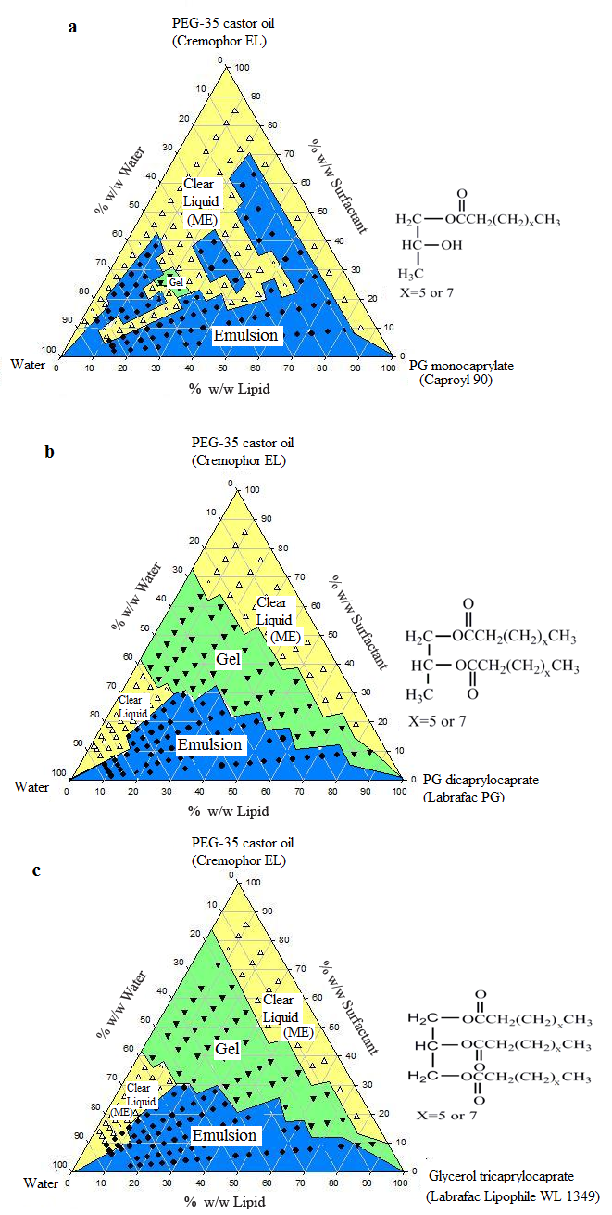
Figure 1 Phase diagrams of (a) PG monocaprylate, (b) PG dicaprylocaprate, and (c) glycerol tricaprylocaprate in combination with Cremophor EL (PEG-35 castor oil) and water. Key: Emulsion;Gel; Clear liquid. The chemical structure of the primary component of the lipid used is given next to each phase diagram.

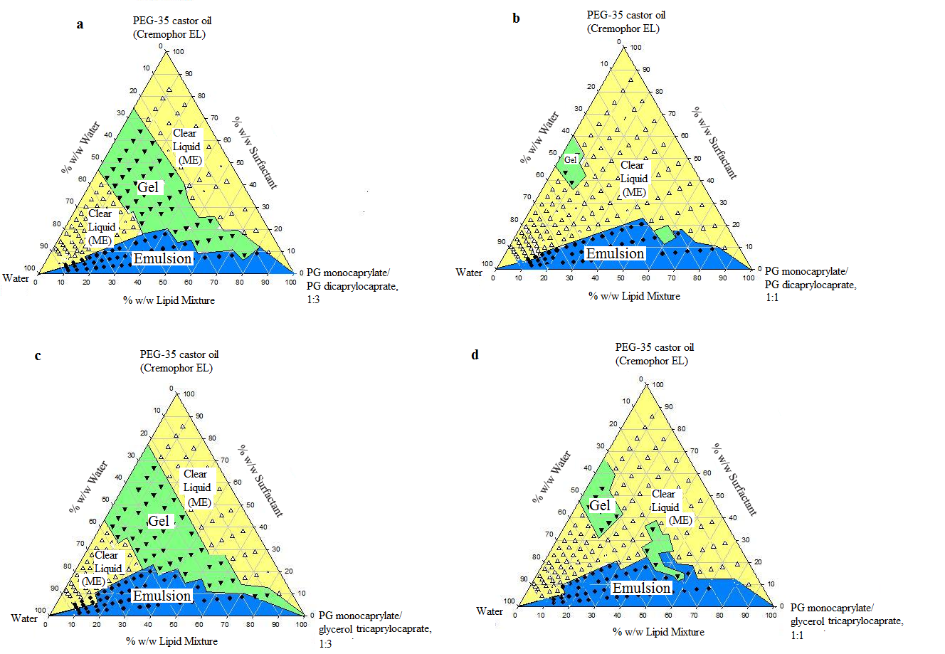
Figure 2 Phase diagrams of lipid mixtures in combination with Cremophor EL (PEG-35 castor oil) and water. Lipid mixtures used: (a) PG monocaprylate + PG dicaprylocaprate, 1:3 w/w; (b) PG monocaprylate + PG dicaprylocaprate, 1:1 w/w; (c) PG monocaprylate + glycerol tricaprylocaprate, 1:3 w/w; and (d) PG monocaprylate + glycerol tricaprylocaprate, 1:1 w/w. Key: Emulsion;Gel; Clear liquid.

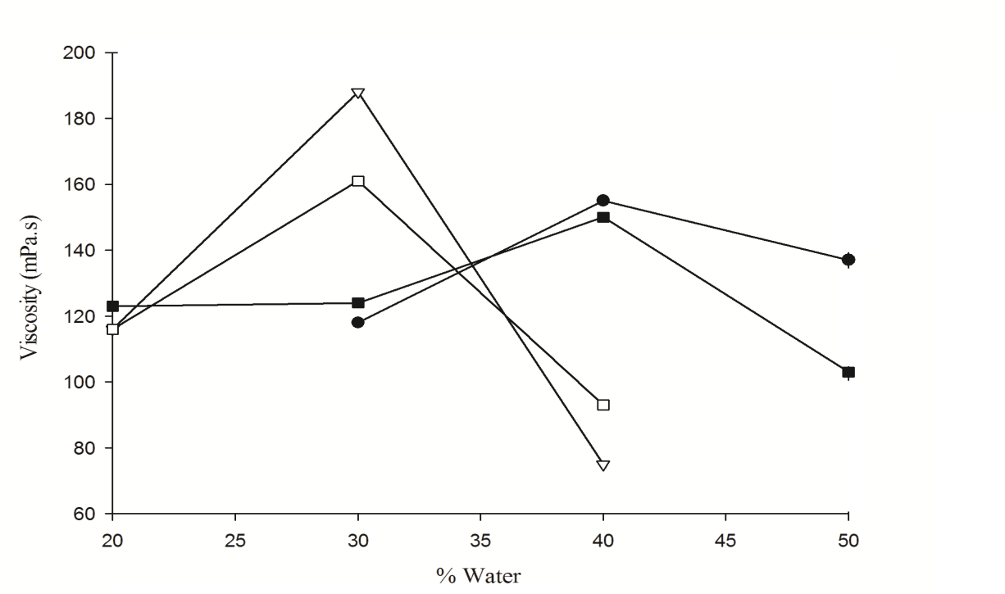
Figure 3 Comparison of viscosities of gels formed by lipid-surfactant mixtures at room temperature in presence of increasing amounts water. Key: , PG dicaprylocaprate + Cremophor EL, 30:70 w/w; , PG dicaprylocaprate + Cremophor EL, 50:50 w/w; , glycerol tricaprylocaprate + Cremophor EL, 30:70 w/w; and
, glycerol tricaprylocaprate + Cremophor EL, 50:50 w/w.

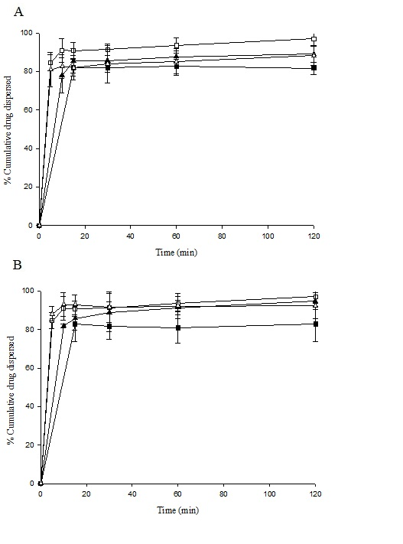
Figure 4 Dispersion profiles of danazol from 50:50 mixtures of lipids and Cremophor EL in 250 mL of 0.01M HCl at 37 ⁰C (n=3). One g of preconcentrate containing 15 mg of danazol was used for each test.
Lipids used (A):, PG monocaprylate; , PG dicaprylocaprate;, PG monocaprylate plus PG dicaprylocaprate, 1:3 w/w; and, PG monocaprylate plus PG dicaprylocaprate, 1:1 w/w.
(B): , PG monocaprylate; , Glycerol tricaprylocaprate; , PG monocaprylate plus glycerol tricaprylocaprate, 1:3 w/w; and, PG monocaprylate plus glycerol tricaprylocaprate, 1:1 w/w.

