Development of Solid SEDDS, II: Application of Acconon C-44® and Gelucire 44/14® as Solidifying Agents for Self-emulsifying Drug Delivery Systems of Medium Chain Triglyceride.

Nrupa Patelª, Hetal N. Prajapatiª, Damon M. Dalrymple^{b}, Abu T.M. Serajuddinª
ªCollege of Pharmacy and Allied Health Professions, St. John’s University, 8000 Utopia Parkway, Queens, NY 11439, USA
^{b}ABITEC Corporation, 501W 1st Avenue, Columbus, OH 43215, USA
Correspondence: Abu T. M. Serajuddin (Telephone: 718-990-7822; Fax: 718-990-1877; E-mail: serajuda@stjohns.edu
ABSTRACT
Self-emulsifying drug delivery systems (SEDDS) are usually isotropic liquids consisting of drugs, lipids, surfactants and/or co surfactants that spontaneously form fine oil-in-water emulsion in contact with water. Since a solid dosage form has better patient acceptance than a liquid, it was investigated whether liquid SEDDS containing medium-chain lipids (mono- or tri-glycerides) may be converted to solids or semisolids using the lauroyl polyoxyl glycerides (Acconon C-44®; ABITEC, and Gelucire 44/14®; Gattefosse) as solidifying agents. Acconon C-44 and Gelucire 44/14 were melted at 65⁰C, the liquid lipids or the liquid lipid-surfactant mixtures, with and without dissolved drug (probucol), were mixed with the melts, and the hot liquid solutions were filled into hard gelatin capsules. The solutions solidified inside capsules when cooled to room temperature. Acconon C-44 and Gelucire 44/14 had greater propensity of solidifying the triglyceride of medium chain fatty acids (Captex 355®; ABITEC) rather than the monoglyceride. The powder XRD, DSC and microscopic analyses indicated that the lauroyl polyoxyl glycerides crystallized at room temperature, while the lipid or the lipid-surfactant mixtures present in the formulations remained interspersed in between solids as a separate liquid phase. The drug remained dissolved in the liquid phase and there was no crystallization of drug. Although Acconon C-44® and Gelucire 44/14® are themselves surface active, the dispersion testing by the USP apparatus II at 50 rpm and 37 ⁰C using 250 mL of 0.01N HCl as the dispersion medium showed that a second surfactant (Cremophor EL®; BASF) was needed in the solid formulation to maximize drug release and dispersion. Formulations containing 1:1 and 3:1 w/w ratios of Captex 355 and Cremophor EL produced lipid particles in the range of 200 to 450 nm. Thus, a novel approach of preparing solid SEDDS is presented that results into very fine emulsion with particle size <500nm.
KEY WORDS: Solid SEDDS, lauroyl polyoxyl glycerides, Acconon C-44, Gelucire 44/14, probucol, dispersion testing

INTRODUCTION
The majority of new chemical entities (NCE) that emerged from the drug discovery pipeline during the past two decades has been extremely insoluble in aqueous media, thus limiting their dissolution rate and oral bioavailability (1, 2). For this reason, there has been great interest in the development of lipid-based drug delivery systems to enhance oral absorption where a water-insoluble drug is solubilized in a mixture of lipid, surfactant and optionally cosurfactant (3-10). Lipid-based formulations are especially suitable for optimizing oral delivery of drugs that are highly lipophilic (8). Depending on whether such solubilized formulations form emulsions or microemulsions in contact with gastrointestinal fluids after oral ingestion, they are referred to as self-emulsifying drug delivery system (SEDDS) or self-microemulsifying drug delivery systems (SMEDDS) (11, 12). Despite a very large number of NCE that are potential candidates for oral absorption and bioavailability enhancement by lipid-based drug delivery, the commercial application of the system has been limited (13, 14). Mullertz (15) reported that as of 2010 there were only five marketed drugs (ciprofloxacin, cyclosporine A, lopinavir, ritonavir and tipranavir) for which the technology has been successfully applied for dissolution and bioavailability enhancement.

One of the two major issues that limit greater application of lipid-based delivery systems in the development of drug products is the inadequate solubility of some of the NCEs in suitable lipids or lipid-surfactant mixtures. Since the drug is usually dissolved in liquid lipids or lipid-surfactant mixtures, the other major issue is that the drug products are also liquids that require packaging in bottles or encapsulation in soft gelatin capsules. However, the solid dosage form is the most preferred formulation approach for oral administration of drugs as over 80% of marketed drug products in the US are either tablet or hard gelatin capsule. In addition, when the availability of drug substance is limited and the timeline is short at the early stage of drug product development, many formulators do not consider soft gelatin encapsulation as a preferred dosage form development approach as it often requires outsourcing of the manufacturing process to contract laboratories. One focus of the recent research efforts in our laboratory has been the development of lipid-based formulations in solid or semisolid forms that may be filled in hard gelatin capsules, thus obviating the need for liquid formulations.

There are various reports in the literature on the development of solid and semisolid dosage forms of lipids or lipid-like materials (16, 17). In general, such formulations utilized solid or semisolid amphiphilic lipids like lauroyl polyoxyl glycerides (Gelucire® 44/14) (18, 19) and d-α-tocopheryl polyethylene glycol 1000 succinate (TPGS) (5, 20) as vehicles for drugs. The drugs were first dissolved in molten vehicles at an elevated temperature and the hot solutions are filled into hard gelatin capsules, which then solidified once cooled to room temperature. However, since the vehicles crystallized out when they solidified at room temperature, there was the potential that the drugs could phase separate from solutions in amorphous or crystalline forms (21). Therefore, such formulations were solid dispersions of amorphous (or crystalline) drugs rather than solutions of drugs in lipids (16, 22). Even when the drug initially remained amorphous in solid dispersions, there was the potential that the drug could crystallize out during shelf-life (21). All of these could defeat the purpose of developing a lipid-based formulation, where it is expected that the drug would remain in solution in the dosage form.

In 2009, Serajuddin and his colleagues (23) reported a novel approach of preparing solid lipid-based formulations where solutions of drug in liquid lipid-surfactant mixtures were converted into solid forms by incorporating them in a solid polyethylene glycol (PEG) matrix. For this purpose, the formulations containing drug, lipid, surfactant and PEG 3350 (m.p. 55–60⁰C) were heated to ~70⁰C, and the hot mixtures were filled into hard gelatin capsules. Upon cooling to room temperature, the formulation solidified, where the crystalline PEG 3350 formed the solid structure and the liquid lipid-surfactant mixture containing the dissolved drug dispersed in between PEG 3350 crystals as a separate phase. More recently, Shah and Serajuddin (24) developed another solid lipid-based formulation where poloxamer 188 was used as the solidifying agent in place of PEG 3350. Another added advantage of the formulation was that poloxamer 188 also served as the emulsifying agent for lipids used. It was, however, observed in both of these studies that only the monoglycerides of medium chain fatty acids were amenable to solidification by PEG 3350 or poloxamer 188; the formulations could contain as much as 70-80% w/w liquid content. No such solidification of PEG 3350 and poloxamer 188 observed when di- or tri-glycerides of medium chain fatty acids were used.

Since triglycerides of fatty acids, especially those of medium chain acids, are commonly used in lipid-based formulations, further studies have been conducted in our laboratory to identify solidifying agents for formulations containing triglycerides. Preliminary studies indicated that lauroyl polyoxyl glyceride could serve as a suitable solidifying agent for triglyceride formulations. The present report describes preparation and physicochemical characterization of solid lipid-based formulations using lauroyl polyoxyl glycerides as the carrier that may be delivered as solid dosage forms using hard gelatin capsules. The solid carrier is an amphiphilic (HLB ~14) and semisolid (m.p. ~ 44⁰C) excipient that is listed as lauroyl polyoxyl-32 glycerides in the United States Pharmacopoeia (USP-NF) and lauroyl macrogol-32 glycerides in the European Pharmacopoeia (EP). Since the excipient is obtained semi-synthetically from natural sources and contains multiple components, there could be variation in its properties depending on its sources. For this reason, materials obtained from two manufactures (Acconon C-44 ®, ABITEC; Gelucire 44/14®, Gattefosse) were used to determine whether there is any impact of the source on its performance as the solidifying agent for triglycerides. Probucol, which is a neutral molecule with an aqueous solubility of 0.002-0.005 μg/ml and an octanol-water logP value of 11 (25, 26), was used as a model drug to study the drug release from different solid formulations developed.

MATERIALS AND METHOD

Materials
Captex® 355 EP/NF (caprylic/capric triglyceride), Capmul® MCM NF (Glyceryl caprylate/caprate), Capmul® PG-8 NF (propylene glycol monocaprylate) and Acconon® C-44 (lauroyl polyoxyl-32 glycerides, EP/NF) were supplied by ABITEC Corp., Columbus, OH, USA. Gelucire® 44/14 (lauroyl polyoxyl-32 glycerides, EP/NF) was obtained from Gattefosse Corp., Paramus, NJ, USA. Cremophor® EL (PEG-35 castor oil) was obtained from BASF Corp., Tarrytown, USA. Probucol was purchased from Sigma Aldrich, St. Louis, MO, USA. All other chemicals and reagents used were of analytical grade or better.

Methods

Preparation of Formulation

Preliminary studies were conducted to determine whether lipids and liquid surfactant were able to form solid systems with Acconon C-44 and Gelucire 44/14. Initially, the ability of Acconon C-44 and Gelucire 44/14 to solidify different lipids, such as Captex 355 (triglyceride), Capmul MCM (a monoglyceride) and Capmul PG-8 (a propylene glycol monoester), at room temperature were determined. Samples were prepared at lipid to solidifying agent (Acconon C-44 or Gelucire 44/14) ratios 7:3, 6:4, 1:1, 4:6, and 3:7 w/w by melting the solidifying agents at ~65ºC and then mixing various lipids with them at the elevated temperature. When the hot mixtures were cooled to room temperature (~20-25ºC), it was observed that only Captex 355 solidified at all ratios with both Acconon C-44 and Gelucire 44/14, i.e., as high as 70% lipid content in the formulation. On the other hand, when Capmul MCM and Capmul PG-8 were used as lipids, the mixtures either did not solidify or solidified only at low lipid to solidifying agent ratios. Therefore, only Captex 355 was used as the lipid in further studies with Acconon C-44 or Gelucire 44/14.

Although the mixtures of Captex 355 with Acconon C-44 or Gelucire 44/14 solidified at room temperature, the formulations did not disperse in aqueous media to form microemulsion or emulsion. Rather, there was a phase separation of Captex 355 from aqueous media. In other words, despite their amphiphilic nature, Acconon C-44 and Gelucire 44/14 were not able to emulsify the triglyceride. For this reason, one additional surface active agent, Cremophor EL, which could also be solidified by Acconon C-44 or Gelucire 44/14, was incorporated in the system. Captex 355 and Cremophor EL were first mixed at 1:1 and 3:1 ratios, and the drug, probucol, was dissolved in them at 60 mg/g concentration. The solutions were then mixed with molten Acconon C-44 or Gelucire 44/14 at the elevated temperature of ~65ºC in 20-mL glass scintillation vials placed on hot plates. All samples were also vortexed for 2-3 minutes in the molten state to attain homogeneous mixing. The hot solutions were manually filled into #00 hard gelatin capsules (~1g). The capsules were stored at room temperature for at least 48 hours to ensure complete solidification of their contents before analysis. Formulations without the incorporation of drug were also filled in capsules to serve as controls.

Characterization of formulation

All the solid preconcentrates containing Acconon C-44 and Gelucire 44/14 formed upon cooling, with and without drug, were characterized by powder-X-ray diffractometry and differential scanning calorimetry. Selected solid systems were also examined microscopically to observe their microstructures.

Powder X-ray diffractometry (P-XRD)

The P-XRD study was performed at room temperature using an X-ray diffractometer (X-ray Diffractometer XRD-6000, Shimadzu, Kyoto, Japan). The diffraction patterns were measured with a voltage of 40 kV and a current of 30 mA over a 2θ range of 10-80º using a step size of 0.02º at a scan speed of 4º/ minute. The P-XRD intensities of solid preconcentrates were compared by measuring approximate peak intensities at 2θ = 23.1º and 23.2º, respectively, for Acconon C-44 and Gelucire44/14.

Differential scanning calorimetry (DSC)

The thermal characteristics of the solidifying agents (Acconon C-44 and Gelucire 44/14) and various formulations were determined by DSC (Pyris Diamond DSC-7, Perkin-Elmer, Waltham, MA, USA). Samples, accurately weighed in the range of 2 to 5 mg, were sealed into aluminum pans by crimping. The scans for all samples were recorded after holding for 5 min at the starting temperature (20ºC) and then heating from 20 to 60ºC with a heating rate of 5ºC/min under an extra dry nitrogen gas purge (20mL/min).

Microscopic examination

Solid preconcentrates were analyzed using an optical microscope fitted with cross-polarizing lenses (Nikon Microscope Eclipse 50i, Morrell Instrument Co., Melville, NY, USA) and a confocal fluorescence microscope (Leica Microsystems Inc., Exton, PA, USA) with the wavelengths of 514 nm for excitation and 550 - 605 nm for emission and using the bandpass filter of DD458-514 nm. The optical microscopic images were captured using Nikon Digital Camera (DS 5000, Nikon Inc., Melville, NY, USA) with magnification of X100. For fluorescence microscopy, Nile red, which is a fluorescent probe for lipid (27), was dissolved in a molten formulation, two drops of the melt was placed on a glass slide and covered with a glass cover slip, and finally the edges of the cover slip were sealed with nail polish. The prepared slides were then allowed to cool in two different ways: (a) letting them to cool under ambient condition (shock cooling) and (b) cooling in an oven (GCA/Precision Scientific, Chicago, IL, USA) from ~60 to 25ºC at the rate of 0.1ºC/min (controlled cooling).

Dispersion Testing

The efficiency of self-emulsification and dispersion of solid systems were assessed by the USP apparatus II (Paddle method; Distek Inc., NJ, USA) at 50 rpm and 37⁰ C using 250 mL 0.01N HCL (pH~2) as dispersion medium. Pipettes with siliconized tips were used to withdraw the aliquots from the dispersion vessels. Aliquots withdrawn from each vessel at 10,15, 30, 45, 60, 120 and 180 min were placed in disposable plastic cuvettes (Beckman Coulter disposable cell, Beckman Coulter Inc., CA, USA) for particle size using Delsa Nano C Particle Analyzer (Beckman Coulter, Beckman Coulter Inc., CA, USA). Unfiltered samples were also analyzed for drug concentration in dispersion media; the aliquots were not filtered as it reduced drug concentration since some of the oil droplets in the dispersion fluid could be larger than the pore size of the 0.45 µm filter used. The volume of the dispersion medium in each vessel was kept constant by replacing the same volume of aliquot withdrawn with 0.01N HCl. To evaluate the effect of drug loading on emulsification of lipids from solid systems, the dispersion test and the particle size analysis were also conducted on formulations without the drug present. All experiments were carried out in triplicates.

HPLC analysis
The HPLC analysis of probucol was conducted using a quaternary pump, an Agilent 1100 autosampler and a diode array detector (HP 1100 series, Agilent Technologies, Wilmington, DE, USA). The chromatographic column used was C₈ Waters X-Bridge column (3.5µm), 4.6 mm x 150 mm. A methanol-water mixture (95:5 v/v) was used as the mobile phase at a rate of 1 mL/min, and the detection wavelength was set at 243 nm.

RESULTS AND DISCUSSION

Development of solid lipid-based formulations
The ability of lauroyl polyoxyl glycerides (Acconon C-44 and Gelucire 44/14) to solidify monoesters and triesters of medium chain fatty acids were compared in the present study. The monoesters used were glyceryl caprylate/caprate (Capmul MCM) and PG monocaprylate (Capmul PG-8), while the triester used was caprylic/capric triglyceride (Captex 355). It was determined by powder X-ray diffraction studies that Capmul PG-8 could not be solidified by any of the solidifying agents used (Acconon C-44 or Gelucire 44/14), while Capmul MCM could not be solidified by Gelucire 44/14 at all and Acconon C-44 could solidify it only at low lipid content in the mixture (40% w/w and lower). In contrast, the triester (triglyceride) Captex 355 could be solidified at all lipids to surfactant ratios used (3:7 to 7:3, w/w), i.e., up to 70% w/w lipid could be solidified by Acconon C-44 and Gelucire 44/14. The powder XRD patterns of Captex 355-Acconon C-44 and Captex 355-Gelucire 44/14 mixtures in Fig. 1 confirm the crystallinity of the solidifying agents in the mixtures. These results are contrary to what were observed earlier with PEG 3350 (23) and poloxamer 188 (24) as solidifying agents, which solidified monoesters and not the triesters. Thus, the results of the present study demonstrate a novel approach of solidifying triglycerides in dosage forms by using lauroyl polyoxyl glycerides as solidifying agents.

As mentioned earlier in the experimental section, the lipid (Captex 355) did not disperse in aqueous media to form emulsion or microemulsion when it was formulated alone with Acconon C-44 or Gelucire 44/14 and an additional surfactant was necessary to disperse the lipid in aqueous media. The powder XRD in Fig. 2 shows that Cremophor EL, which serves as an excellent dispersing agent for lipids in aqueous media (11, 12) could also be solidified by Acconon C-44 and Gelucire 44/14. Further, the 1:1-mixture of Captex 355 and Cremophor EL could be solidified by Acconon C-44 and Gelucire 44/14 (Fig. 3). The results similar to those in Fig. 3 could be obtained when Captex 355 and Cremophor EL were used at other ratios (e.g., 3:1 and 1:3 w/w). These results, therefore, show that the lipid-based systems consisting of the triglyceride of medium chain fatty acids and a suitable surfactant may also be solidified by lauroyl polyoxyl glycerides (Acconon C-44 or Gelucire 44/14).

Physicochemical characterization of solid lipid-based formulations

Powder X-ray diffractometry (P-XRD)
Neat Acconon C-44 and neat Gelucire 44/14 are solid at room temperature. Their powder X-ray diffraction patterns in Fig. 1 showed similar crystalline peaks for both of them at 2θ = 19.1º and 23.1º.As the liquid Captex 355, Cremophor EL or the mixture of Captex 355 and Cremophor EL were added to the solid lauroyl polyoxyl glycerides, the consistency of the solids gradually changed from solid to semisolid, and, visually, the liquid appeared to be uniformly distributed in the solid matrices as there were no phase separation or syneresis of liquids. Fig. 1, 2 and 3 show the P-XRD patterns of Acconon C-44 and Gelucire 44/14 with increasing concentrations of, respectively, Captex 355, Cremophor EL, and the 1:1-mixture of Captex 355 and Cremophor EL. Characteristic powder XRD patterns of Acconon C-44 and Gelucire 44/14 were observed. The intensity of the peaks decreased and there were bigger amorphous hallows in the XRD patterns as the fraction of the liquid component (lipid, surfactant or their mixtures) in the solid or semisolid systems increased. The reduction in intensity of P-XRD peaks with the addition of lipid, surfactant or the lipid-surfactant mixture was also in agreement with the change in consistency of solids to semisolids. The consistency of the mixtures was still hard enough that they could be formulated as solid dosage forms in hard gelatin capsules.

Figs. 1, 2 and 3 represent powder XRD patterns of solid systems without any drug present. There was no change in the XRD patterns due to the presence of probucol in the solid systems (data now shown), indicating that the presence of drug did not have any impact in the crystallinity of Acconon C-44 and Gelucire 44/14. There were also no drug peaks present. For some samples containing probucol, the powder XRD analysis was repeated after 3 months of storage at room temperature, where no change in XRD patterns was observed, indicating that the solid systems are physically stable. Further, the similar powder XRD patterns of neat Acconon C-44 and Gelucire 44/14 and their mixtures with lipid and surfactant in Figs. 1, 2 and 3 demonstrate that both solidifying agents have similar crystallinity and behave similarly in dosage forms.

Differential Scanning Calorimetry (DSC)
The results of the DSC study of neat Acconon C-44 and Gelucire 44/14 and various formulations developed in the present investigation are in agreement with the P-XRD analysis. Fig. 4 shows DSC scans of Acconon C-44 and Gelucire 44/14 and their combinations with the Captex 355-Cremophor EL mixture. The melting points of neat Acconon C-44 and Gelucire 44/14 were observed to be ~ 44º C. Melting endotherms of the solids broadened and peak melting temperatures decreased as liquid Captex 355, Cremophor EL or the Captex 355-Cremophor EL mixture was added to them. Fig. 4 shows the DSC scans obtained when increasing amounts of the 1:1-Captex 355-Cremophor EL mixture was added to Acconon C-44 (Fig. 4A) and Gelucire 44/14 (Fig. 4B), where endotherms, although broadened, were observed with the liquid component as high as 70% w/w. The lowering of the endothermic peaks is in agreement with the visual observation that Acconon C-44 and Gelucire 44/14 gradually changed from solid to semisolid with the addition of increasing amounts of liquid components. There was no change in DSC scans when the model drug probucol was incorporated in the formulations. In agreement with the P-XRD results, Acconon C-44 and Gelucire 44/14 maintained their crystallinity in presence of the liquid components in proportion to their concentrations in the formulations. The enthalpy of melting of Acconon C-44 and Gelucire 44/14 decreased linearly as concentrations of the solidifying agents decreased, i.e., the concentration of the lipid-surfactant component increased. Similar results were earlier reported by Li et al. (23).

Microscopic examination
The microstructure of solid lipid-based systems is shown in Fig. 5. The optical microscopic images show that the liquid mixture (Captex 355 and Cremophor EL) exists as a separate phase trapped into solid lauroyl polyoxyl glyceride clusters (Fig. 5B and C). To bolster the results of optical microscopy, the confocal fluorescence microscopic examination was performed using Nile red as the fluorescent probe to visualize the non-crystalline region of the system. Again, two phases were detected with crystalline spherulites of polyoxyl glycerides (visualized in white) and a liquid mixture (visualized in red) located in between polyoxyl glyceride domains (Fig. 5D).

There are several reports in the literature showing that solid polyethylene glycols (PEG) form crystalline spherulites upon cooling from the melt (28, 29, 30). As seen from Fig. 5A, the cross-polarized optical microscope image of the neat lauroyl polyoxyl glyceride also shows birefringent image of crystalline spherulites. There were only minimal gaps observed between spherulites in Fig. 5A, and with the addition of the lipid-surfactant mixture, the gap between the spherulites increased. It was reported earlier that polymeric materials like solid PEG may contain both crystalline and amorphous domains and a liquid may be trapped in the amorphous regions of the polymeric structures (31). It appears that a similar mechanism exists in the trapping or immobilization of the liquid lipid and surfactant by lauroyl polyoxyl glycerides (Fig. 5B and C).

It was reported in the literature that the cooling rate of melts may have a major impact on the spherulite formation (32). Such an effect was also observed in the present study. Fig 5B shows the photomicrograph of a solid system containing 50% liquid (1:1 w/w Captex 355 and Cremophor EL) and 50% lauroyl polyoxyl glycerides, where the glass slide containing the molten formulation was suddenly exposed to room temperature. Since the fast cooling did not allow spherulites to grow, irregular, needle-shaped crystals of lauroyl polyoxyl glycerides were observed in Fig. 5B. In contrast, Fig.5C shows the microscopic image where the glass-slides were cooled at a controlled rate from 60 º C to room temperature (~ 25º C) over a period of 4 hours in an oven to allow spherulites to grow. Thus, when the molten preconcentrate was cooled slowly at a controlled rate, the spherulites were well-defined as shown in Fig.5C. Unlike the neat polyoxylglycerides, the spherulites were separate apart from each other due to the presence of a liquid phase in between them. The confocal fluorescent microscopic image in Fig. 5D further differentiates the two phases in the solid system. Since the Nile red dye is soluble only in the lipid phase (27), the figure clearly shows that the lipid was trapped in the microstructure of lauroyl polyoxyl glycerides.

Dispersion Test
The dispersion test was performed to determine how easily formulations emulsified and whether the drug precipitated during dispersion. Both Acconon C-44 and Gelucire 44/14 dispersed completely in aqueous media. However, when Captex 355 alone was mixed with them, the lipid did not disperse in aqueous media. Despite their amphiphilic nature, the solidifying agents did not have adequate surface activity to emulsify the lipid as large oil globules floating on surfaces of dispersion media were observed. Therefore, based on the results of earlier studies in our laboratory (12), a second surfactant, Cremophor EL, that has good emulsifying properties for Captex 355 was incorporated in the system. The dispersion profiles of the solid systems of 1:1 and 3:1 mixture of Captex 355 and Cremophor EL produced by using Acconon C-44 and Gelucire 44/14, respectively, are shown in Figs. 6 and 7. The exposure of the formulation containing Captex 355-Cremophor EL mixture to 0.01N HCl resulted in opaque emulsions within 35 to 40 min. In all formulations, the drug release was more than 90% at the end of 3h.

During dispersion testing, the particle size analysis of each sample was performed, and the results are shown in the Figs. 8 and 9. In solid systems containing lipid, the particle sizes of lipid globules produced in dispersion media were in the range of 200 to 450 nm. There was no significant effect of the presence of drug on particle size. Although only dispersion test data at pH 2 (0.01N HCl) are reported in the present paper, separate tests at pH 6.8 showed that there was no effect of pH on dispersion of probucol and the particle size of lipid globules. This is possibly because the drug as well as the lipids and the surfactant used are neutral and their physical and chemical properties are not pH-dependent.

Microemulsion was not formed by all formulations; however, the particles were in submicron range (<650nm). The particle size analysis of the solid system was conducted where the solidifying agent was kept constant at 30% and the remaining 70% liquid component had varying amounts of Captex 355 and Cremophor EL. These results indicated that the particle size of oil globules decreased to microemulsion range with an increase in Cremophor EL concentration in the formulation.

Several aliquots during dispersion testing were examined microscopically for the formation of any birefringent drug crystals; however, no such crystals were observed. The centrifugation of aliquots (up to 8000 RMP) also did not exhibit any separation of solid phase. Further, as shown in Figs. 8 and 9, there was no significant change in particle size with time during the dispersion test. These findings led to the conclusion that that there was no precipitation of drug from solid formulations upon dispersion in aqueous media, and, if there were any, the drug was amorphous and had the same particle size as that of the emulsion globules.

CONCLUSION
The results of the present study provides a novel approach in developing solid self-emulsifying lipid-based drug delivery system, where liquid medium-chain triglyceride may be incorporated in the solid microstructure of lauroyl polyoxyl glyceride (Acconon C-44 and Gelucire 44/14). Although Acconon C44 and Gelucire 44/14 are surface active in nature, a co-surfactant was needed to enhance dispersion and drug release from the system. Moreover, the solid may be filled in hard gelatin capsules with the advantage of drug being in the solubilized state in the lipid. As the model drug probucol remained in the solubilized state in lipids, no phase separation or crystallization of drug were observed. The formulations dispersed in aqueous media producing fine particles of lipids in the range of 200 to 450 nm with the drug remaining dissolved in the lipid globules.

ACKNOWLEDGEMENTS AND DISCLOSURE
This study was supported, in part, with a generous research grant from ABITEC Corporation, 501 W 1st Avenue, Columbus, OH 43215 to St. John’s University. The authors thank Gattefosse Corp., Paramus, New Jersey, USA, for the donation of Gelucire® 44/14 and BASF Corp., Tarrytown, New York, USA, for the donation of Cremophor® EL. They also thank Mr. Louis E. Bryan of the Department of Biological Sciences, St. John’s University for his assistance in confocal fluorescence microscopic analysis of samples.

REFERENCES
1. Lipinski C.A., Lombardo F., Dominy B.W., Feeney P.J., Experimental and computational approaches to estimate solubility and permeability in drug discovery and development settings, Adv. Drug. Del. Rev., 23:3-25, 1997
2. Lipinski C.A., Drug-like properties and the causes of poor solubility and poor permeability, J. Pharmacol. Toxicol. Methods, 44:235-249, 2000
3. Charman S.A., Charman W.N., Rogge M.C., Wilson T.D., Dutko F.J., Pouton C.W., Self-emulsifying drug delivery systems: formulation and biopharmaceutic evaluation of an investigational lipophilic compound, Pharm. Res., 9:87-93, 1992
4. Shah N.H., Carvajal M.T., Patel C.I., Infeld M.H., Malick A.W., Self-emulsifying drug delivery systems (SEDDS) with polyglycolyzed glycerides for improving in vitro dissolution and oral absorption of lipophilic drugs, Int. J. Pharm., 106:15-23, 1994
5. Khoo S.M., Porter C.J.H., Charman W.N., The formulation of Halofantrine as either non-solubilising PEG 6000 or solubilising lipid based solid dispersions: Physical stability and absolute bioavailability assessment, Int. J. Pharm., 205:65-78, 2000
6. Caliph S.M., Charman W.N., Porter C.J.H., Effect of short‐, medium‐, and long‐chain fatty acid‐based vehicles on the absolute oral bioavailability and intestinal lymphatic transport of halofantrine and assessment of mass balance in lymph‐cannulated and non‐cannulated rats, J. Pharm. Sci., 89:1073-1084, 2000
7. Odeberg J.M., Kaufmann P., Kroon K.G., Höglund P., Lipid drug delivery and rational formulation design for lipophilic drugs with low oral bioavailability, applied to cyclosporine, Eur. J. Pharm. Sci., 20:375-382, 2003
8. Porter C.J.H., Trevaskis N.L., Charman W.N., Lipids and lipid-based formulations: optimizing the oral delivery of lipophilic drugs, Nature Rev., 6:231-248, 2007
9. O'Driscoll C.M., Griffin B.T., Biopharmaceutical challenges associated with drugs with low aqueous solubility - the potential impact of lipid-based formulations, Adv. Drug. Del. Rev., 60:617-624, 2008
10. Serajuddin A.T.M., Li P., Haefele T.F., Development of lipid-based drug delivery systems for poorly water-soluble drugs as viable oral dosage forms, American Pharmaceutical Review, 11:34-42, 2008
11. Prajapati H.N., Dalrymple D.M., Serajuddin A.T.M., A Comparative evaluation of mono-, di-and triglyceride of medium chain fatty acids by lipid/surfactant/water phase diagram, solubility determination and dispersion testing for application in pharmaceutical dosage form development, Pharm. Res., 29:285–305, 2012
12. Prajapati H.N., Patel D.P., Patel N.G., Dalrymple D.M., Serajuddin A.T.M., Effect of Difference in fatty acid chain lengths of medium-chain lipids on lipid-surfactant-aater phase diagrams and drug solubility, J.Excipients Food Chem., 2(3):73-87, 2011
13. Hauss D.J., Oral lipid-based drug delivery—a case of implementation failing to keep up with innovation. American Pharmaceutical Review, 5:22-36, 2002
14. Strickly R.G., Currently marketed oral lipid-based dosage forms: Drug products and excipients, in Hauss D (ed.), Lipid-based formulations for oral drug delivery: Enhancing bioavailability of poorly water-soluble drug; Informa Healthcare, New York, NY, pp. 1-31, 2007
15. Mullertz A., Ogbonna A., Ren S., Rades T., New perspectives on lipid and surfactant based drug delivery systems for oral delivery of poorly soluble drugs, J. Pharm. Pharmacol., 62:1622-1636, 2010
16. Vasanthavada M., Serajuddin A.T.M., Lipid-based self-emulsifying solid dispersions, in Hauss D (ed.), Lipid-based formulations for oral drug delivery: Enhancing bioavailability of poorly water-soluble drug; Informa Healthcare, New York, NY, 149-184, 2007
17. Jannin V., Musakhanian J., Marchaud D., Approaches for the development of solid and semi-solid lipid-based formulations, Adv. Drug. Del. Rev., 60:734-746, 2008
18. Serajuddin A., Sheen P.C., Mufson D., Bernstein D.F., Augustine M.A., Effect of vehicle amphiphilicity on the dissolution and bioavailability of a poorly water‐soluble drug from solid dispersions, J. Pharm. Sci., 77:414-417, 1988
19. Aungst B.J., Nguyen N.H., Rogers N.J., Rowe S.M., Hussain M.A., White S.J., Shum L., Amphiphilic vehicles improve the oral bioavailability of a poorly soluble HIV protease inhibitor at high doses, Int. J. Pharm. 156:79-88, 1997
20. Varma M.V.S., Panchagnula R., Enhanced oral paclitaxel absorption with vitamin E-TPGS: Effect of solubility and permeability in vitro, in situ and in vivo, Eur. J. Pharm. Sci. 25:445-453, 2005
21. Serajuddin A.T.M., Solid dispersion of poorly water‐soluble drugs: early promises, subsequent problems, and recent breakthroughs, J. Pharm. Sci. 88:1058-1066, 1999
22. Vasanthavada M., Tong W.Q., Serajuddin A.T.M., Development of solid dispersions for poorly water-soluble Drug, in R.Liu (ed.), Water-insoluble drug formulations; Informa Healthcare, New York, NY, 149-184, 2008
23. Li P., Hynes S.R., Haefele T.F., Pudipeddi M., Royce A.E., Serajuddin A.T.M., Development of clinical dosage forms for a poorly water‐soluble drug II: Formulation and characterization of a novel solid microemulsion preconcentrate system for oral delivery of a poorly water‐soluble drug, J. Pharm. Sci. 98:1750-1764, 2009
24. Shah A., Serajuddin A.T. M., Development of Solid SEDDS, I: Use of Poloxamer 188 as both solidifying and emulsifying agent, Pharm. Res., DOI 10.1007/s11095-012-0704-x (published online: 28 February, 2012)
25. Yagi N., Terashima Y., Kenmotsu H., Sekikawa H., Takada M., Dissolution behavior of probucol from solid dispersion systems of probucol polyvinylpyrrolidone, Chem. Pharm. Bull., 44:241-244. 1996

26. Zaghloul A., Khattab I., Nada K.A., Al-Saidan S., Preparation, characterization and optimization of probucol self-emulsified drug delivery system to enhance solubility and dissolution, Pharmazie, 9: 654-660, 2008

27. Greenspan P., Fowler S.D., Spectrofluorometric studies of the lipid probe,
Nile red, J. Lipid Res., 26: 781-9, 1985
28. Strawhecker K., Manias E., Crystallization behavior of poly (ethylene oxide) in the presence of Na montmorillonite fillers, Chemistry of Materials 15:844-849, 2003
29. Gines J., Arias M., Moyano J., Sanchez-Soto P., Thermal investigation of crystallization of polyethylene glycols in solid dispersions containing oxazepam, Int. J. Pharm., 143:247-53, 1996
30. Gránásy L., Pusztai T., Tegze G., Warren J.A., Douglas J.F., Growth and form of spherulites. Physical Review E, 72:011605, 2005
31. Morris K.R., Knipp G.T., Serajuddin A.T.M., Structural properties of polyethylene glycol—polysorbate 80 mixture, a solid dispersion vehicle, J. Pharm. Sci. 81:1185-1188, 1992
32. Sutananta W., Craig D.Q.M., Newton J.M., An investigation into the effect of preparation conditions on the structure and mechanical properties of pharmaceutical glyceride bases, Int. J. Pharm., 110:75-91, 1994

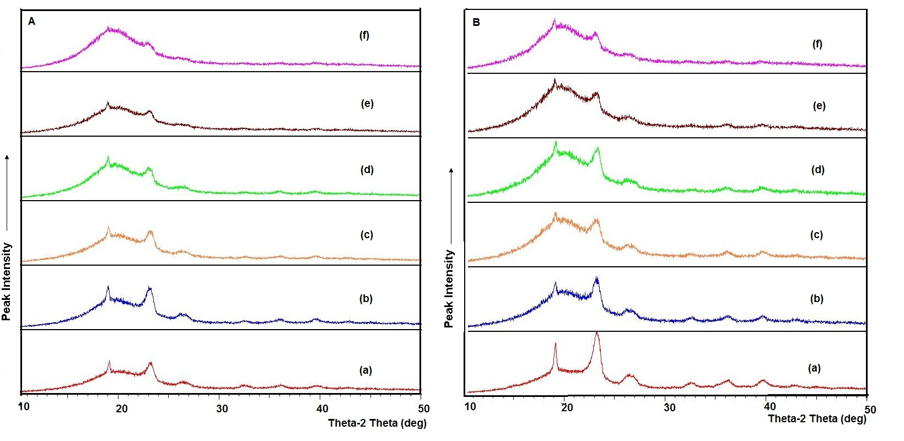
Figure 1 Powder XRD patterns of solid systems containing (A) Captex 355/Acconon C-44 and (B) Captex 355/Gelucire 44/14 mixtures. Key: (a) Neat lauroyl polyoxyl glyceride (Acconon C-44 or Gelucire 44/14), (b) Captex 355/lauroyl polyoxyl glyceride (Acconon C-44 or Gelucire 44/14), 3:7; (c) Captex 355/lauroyl polyoxyl glyceride (Acconon C-44 or Gelucire 44/14), 4:6; (d) Captex 355/lauroyl polyoxyl glyceride (Acconon C-44 or Gelucire 44/14), 1:1; (e) Captex 355/lauroyl polyoxyl glyceride (Acconon C-44 or Gelucire 44/14), 6:4; and (f) Captex 355/lauroyl polyoxyl glyceride (Acconon C-44 or Gelucire 44/14), 7:3.

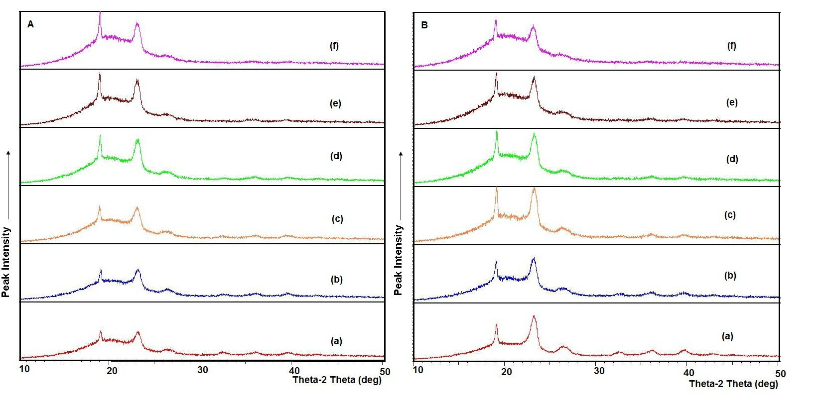
Figure 2 Powder XRD patterns of solid system containing (A) Cremophor EL/Acconon C-44 and (B) Cremophor EL/Gelucire 44/14 mixtures. Key: (a) Neat lauroyl polyoxyl glyceride (Acconon C-44 or Gelucire 44/14) (b) Cremophor EL/lauroyl polyoxyl glyceride (Acconon C-44 or Gelucire 44/14), 3:7; (c) Cremophor EL/lauroyl polyoxyl glyceride (Acconon C-44 or Gelucire 44/14), 4:6; (d) Cremophor EL/lauroyl polyoxyl glyceride (Acconon C-44 or Gelucire 44/14), 1:1; (e) Cremophor EL/lauroyl polyoxyl glyceride (Acconon C-44 or Gelucire 44/14), 6:4; and (f) Cremophor EL/lauroyl polyoxyl glyceride (Acconon C-44 or Gelucire 44/14), 7:3.

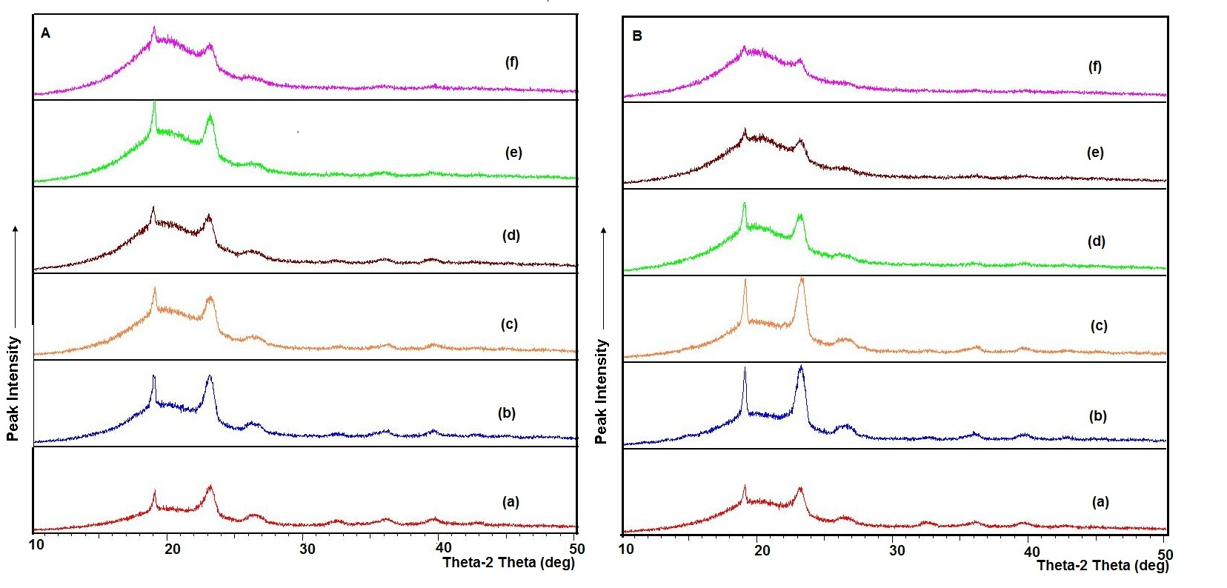
Figure 3 Powder-XRD patterns of solid systems incorporating liquid 1:1-mixture of Captex 355 and Cremophor EL in (A) Acconon C-44 and (B) Gelucire 44/14. Key: (a) Neat lauroyl polyoxyl glyceride (Acconon C-44 or Gelucire 44/14), (b) liquid lipid-surfactant mixture/lauroyl polyoxyl glyceride, 3:7; (c) liquid lipid-surfactant mixture/lauroyl polyoxyl glyceride, 4:6, (d) liquid lipid-surfactant mixture/lauroyl polyoxyl glyceride, 1:1; (e) liquid lipid-surfactant mixture/lauroyl polyoxyl glyceride, 6:4; and (f) liquid lipid-surfactant mixture/lauroyl polyoxyl glyceride, 7:3.

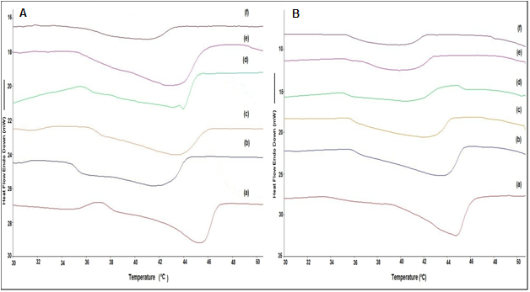
Figure 4 DSC scans of solid systems incorporating liquid 1:1-mixture of Captex 355 and Cremophor EL in (A) Acconon C-44 and (B) Gelucire 44/14. Key: (a) Neat lauroyl polyoxyl glyceride (Acconon C-44 or Gelucire 44/14), (b) liquid lipid-surfactant mixture/lauroyl polyoxyl glyceride, 3:7; (c) liquid lipid-surfactant mixture/lauroyl polyoxyl glyceride, 4:6, (d) liquid lipid-surfactant mixture/lauroyl polyoxyl glyceride, 1:1; (e) liquid lipid-surfactant mixture/lauroyl polyoxyl glyceride, 6:4; and (f) liquid lipid-surfactant mixture/lauroyl polyoxyl glyceride, 7:3.

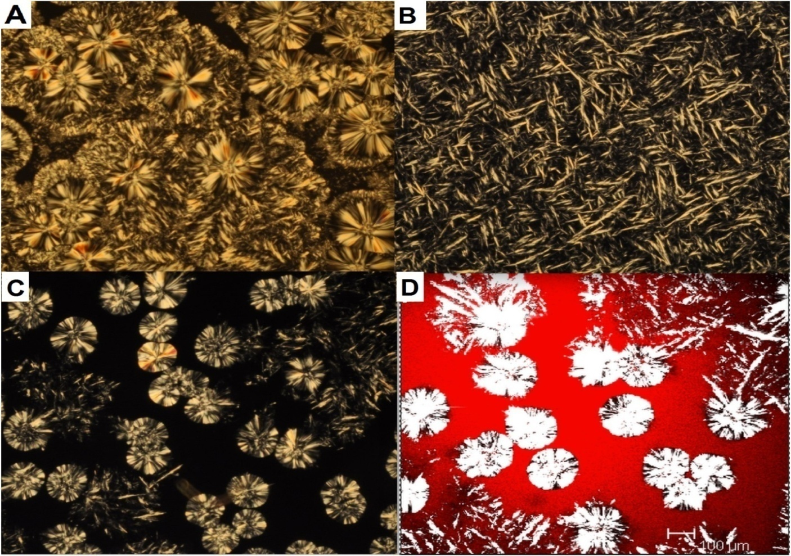
Figure 5 Photomicrographs of solid systems incorporating liquid 1:1-mixture of Captex 355 and Cremophor EL in lauroyl polyoxylglycerides (Acconon C-44). Key: (A) Photomicrograph of neat lauroyl polyoxylglycerides obtained from cross-polarized optical microscope (controlled cooling at the rate of 0.1⁰ C/min); (B) photomicrograph under cross-polarized optical microscope of 1:1 liquid mixture/lauroyl polyoxyl glyceride (1:1) cooled to room temperature by rapid cooling; (C) photomicrograph under cross-polarized optical microscope of 1:1 liquid mixture/lauroyl polyoxyl glyceride (1:1) cooled to room temperature at the controlled rate of 0.1⁰ C/min over a period of 4 hours. ; and (D) confocal fluorescence photomicrograph of 1:1 liquid mixture/lauroyl polyoxyl glyceride (1:1) cooled to room temperature at the controlled rate of 0.1⁰ C/min over a period of 4 h, showing that the Nile red is solubilized in the liquid phase.
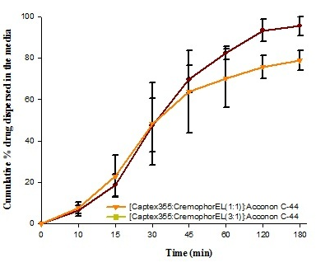
Figure 6 Dispersion profiles of solid formulations (hard gelatin capsule) containing 50% w/w of Acconon C-44 and 50% w/w of liquid lipid-surfactant mixtures (Captex 355 and Cremophor EL at 1:1 and 3:1 w/w ratios) according to the USP apparatus II at 50 RPM using 250 mL 0.01N HCL as dispersion medium at 37 ºC.

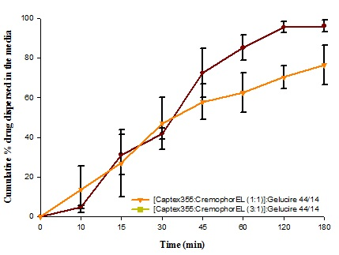
Figure 7 Dispersion profiles of solid formulations (hard gelatin capsule) containing 50% w/w of Gelucire 44/14 and 50% w/w of liquid lipid-surfactant mixtures (Captex 355 and Cremophor EL at 1:1 and 3:1 w/w ratios) according to the USP apparatus II at 50 RPM using 250 mL 0.01N HCL as dispersion medium at 37 ºC.

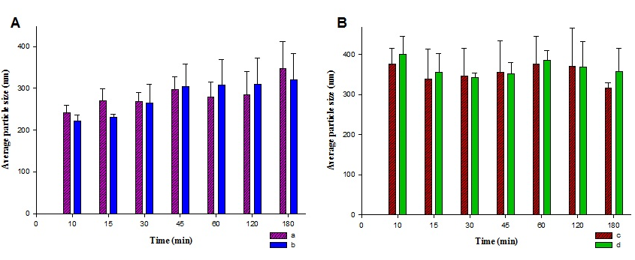
Figure 8 The average particle sizes of emulsion globules produced by (A) the 1:1 w/w mixture of Captex 355 and Cremophor EL and (B) the 3:1 w/w mixture of Captex 355 and Cremophor EL as a function of time, when both mixtures were converted to solid systems using Acconon C-44 as the solidifying agent (50:50 w/w of liquid to Acconon C-44). Key: (a) without drug, (b) with drug, (c) without drug and (d) with drug.

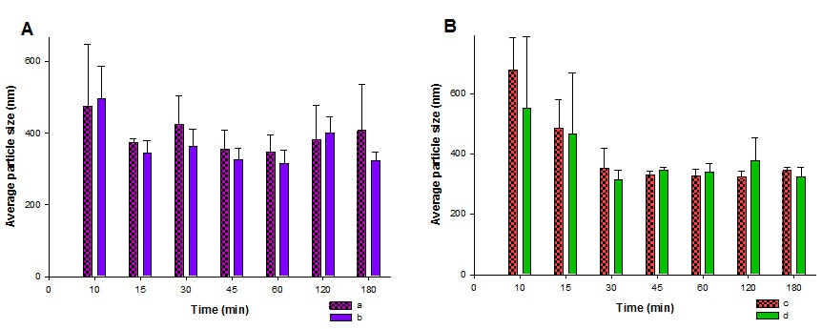
Figure 9 The average particle sizes of emulsion globules produced by (A) the 1:1 w/w mixture of Captex 355 and Cremophor EL and (B) the 3:1 w/w mixture of Captex 355 and Cremophor EL as a function of time, when both mixtures were converted to solid systems using Gelucire 44/14 as the solidifying agent (50:50 w/w of liquid to Gelucire 44/14). Key: (a) without drug, (b) with drug, (c) without drug and (d) with drug.

