Development of Solid SEDDS, III: Application of Acconon C-50® and Gelucire 50/13® as Both Solidifying and Emulsifying Agents for Medium Chain Triglycerides

Nrupa Patelª, Damon M. Dalrymple^{b}, Abu T.M. Serajuddinª
ªCollege of Pharmacy and Allied Health Professions, St. John’s University, 8000 Utopia Parkway, Queens, NY 11439, USA
^{b}ABITEC Corporation, 501W 1st Avenue, Columbus, OH 43215, USA
Correspondence: Abu T. M. Serajuddin (Telephone: 718-990-7822; Fax: 718-990-1877; E-mail: serajuda@stjohns.edu

ABSTRACT

Solid self-emulsifying drug delivery systems (SEDDS) for medium chain triglycerides (Captex 355®, ABITEC) were developed using stearoyl polyoxyl glycerides (Acconon C-50®, ABITEC and Gelucire 50/13®, Gattefosse) as both solidifying and emulsifying agents. Different mixtures of the lipid and each solidifying agent were heated to 65ºC until homogenously mixed clear liquids were formed. Probucol was dissolved as the model drug. The molten mass was then filled in hard gelatin capsules, which upon cooling to room temperature converted to a solid mass inside capsules. The triglyceride could be incorporated in the system to a concentration as high as 80% w/w by still maintaining the solid or semisolid consistency of the system. Powder XRD, DSC, microscopy (cross-polarization and confocal fluorescence techniques), dispersion test and particle size analysis of the solid systems with and without drug were conducted to characterize different formulations. The solidifying agents maintained their crystallinity in solid systems, while the lipids were interspersed in between crystalline regions. The drug remained solubilized in the lipid phase. The formulations dispersed almost completely in 2 h with particle size of the dispersed lipid in the range of 250 to 500 nm when the lipid content in the formulation was up to 50% w/w. Thus, a novel method of developing solid formulations of liquid triglycerides by incorporating lipids in stearoyl polyoxyl glycerides has been developed.

KEY WORDS: Solid SEDDS, stearoyl polyoxyl glycerides, Acconon C-50, Gelucire 50/13, probucol, dispersion testing

INTRODUCTION
In recent years, there has been a great interest in the development of lipid-based drug delivery systems by solubilizing poorly water-soluble and lipophilic drugs in lipids or in mixtures of lipids and surfactants (1-5). For the release of drugs from lipids into the gastrointestinal fluids after oral intake of such formulations, it is essential that the lipids emulsify in aqueous media to increase its surface for partitioning of drugs into aqueous media or for the enzymatic digestion of lipids to enable drug release. Depending on whether they spontaneously form emulsion or microemulsion in presence of water, they are respectively called self-emulsifying or self-micro emulsifying drug delivery systems (SEDDS or SMEDDS, respectively) (6, 7). They are also referred to as emulsion or microemulsion preconcentrates as they, respectively, form emulsion or microemulsion in contact with aqueous media. Since the commonly used lipids and surfactants are liquid at room temperature, they usually result in liquid products.

In recent years, there has been much interest in the development of lipid-based drug delivery systems that are solid at room temperature (8, 9). There are, however, potential stability issues with such dosage forms as the drugs may crystallize out from solid matrices. Li et al. (10) reported a novel method of developing solid lipid-based formulations where the mixture of lipid and surfactant exists as a separate phase interspersed in the solid matrix of polyethylene glycol (PEG) 3350. Later, Shah and Serajuddin (11) reported that lipids alone may be incorporated into the solid matrix of Poloxamer 188, where the matrix serves as both solidifying and emulsifying agents. However, in both of these studies only the monoesters of fatty acids (monoglycerides or propylene glycol monoesters) could be solidified by using PEG 3350 or Poloxamer 188. More recently, it has been observed in our laboratory that a triglyceride may also be solidified by using lauroyl polyoxyl glycerides (Acconon C-44, ABITEC; Gelucire 44/14, Gattefosse) as the solidifying agent (12). As high as 70% w/w of a medium chain triglyceride, Captex 355, could be incorporated in the formulation by still maintaining its solid or semisolid consistency such that the formulation could be developed as hard gelatin capsules. It was, however, noted in this study that, despite being amphiphilic in nature, lauroyl polyoxyl glycerides were unable to disperse or emulsify the triglyceride present when the solid formulation was brought in contact with aqueous media. A second surfactant, Cremophor EL, was necessary to develop a solid formulation that was self-emulsifying. However, there was a maximum amount of liquid component that could be present in the solid system, and, therefore, the addition of Cremophor EL reduced the amount of Captex 355 present. For example, the maximum amount of the triglyceride present in the formulation was only 35% w/w if Acconon C-44 or Gelucire 44/14 could accommodate 70% w/w liquid in the solid system and the liquid was a 1:1-mixture of Captex 355 and Cremophor EL,.

One of the limiting factors in the development of lipid-based drug delivery systems is the limited solubility of drugs in lipids used. Most of the NCEs have relatively low lipid solubility. To maximize the drug load of a formulation, it is essential that lipid content of the formulation should be as high as possible. In our continued efforts to develop solid SEDDS, we observed that stearoyl polyoxyl-32 glycerides (Acconon C-50, ABITEC or Gelucire 50/13, Gattefosse) may serve as both solidifying and emulsifying agents for triglycerides. The excipient is primarily a mixture of PEG 1500 mono- and diesters with palmitic (C₁₆) and stearic (C₁₈) acid with an HLB value of ~13 (13). It was used for the development of solid dispersion hydrophobic drugs (14-18) with the potential for improving oral bioavailability (19, 20). There is, however, a potential that the drug may crystallize out from solid dispersion as both the drug and the carrier are solid at room temperature (8, 21). The present report describes a novel application of Acconon C-50 and Gelucire 50/13, where the drug remains in solution in the liquid triglyceride and the solution can be incorporated in the solid matrix as a dispersed but separate phase. After oral administration, the solid formulation would self-emulsify without the need for any additional surfactant. Stearoyl polyoxyl-32 glycerides from two different manufacturers were used in the present study to determine whether materials from both sources behave similarly. Probucol, a practically water-insoluble compound (0.002-0.005 µg/mL at 25 ºC) with high partition coefficient (LogP = 11), was used as the model drug (22, 23)

MATERIALS AND METHODS
Materials
Acconon® C-50 EP/NF and Gelucire® 50/13 EP/NF (stearoyl polyoxyl-32 glycerides) were, respectively, received from ABITEC Corp., Columbus, OH, USA and Gattefosse Corp., Paramus, NJ, USA. Captex 355 EP/NF (caprylic/capric triglyceride) was supplied by ABITEC Corp. Probucol was purchased from Sigma Aldrich, St. Louis, MO, USA. Nile red, a fluorescence probe for lipids, was purchased from MP Biomedicals, Solon, OH, USA. All other chemicals and reagents used were of analytical grade or better.

Methods

Preparation of Formulation

The samples were prepared using Captex 355 and Acconon C-50 or Gelucire 50/13 at ratios 8:2, 7:3, 6:4, 1:1, 4:6 and 3:7. A batch size of 4 g was prepared in which each solidifying agent was weighed according to its ratios in the mixtures and then melted in glass scintillation vials on a hot plate until a clear solution (~65ºC) resulted. The weighed amounts of lipids were equilibrated at the corresponding temperature and added to the melt. All samples were vortex mixed (2-3 min) in the molten state to ensure homogeneity. The molten mixtures were then manually filled into #00 hard gelatin capsules (~1g). Fill materials of capsules were allowed to solidify at room temperature and stored for at least 48 hours prior to analysis. The solubility of probucol in Captex 355 was determined to be 133 mg/g, and the drug concentration at only 80% of the saturation solubility in the lipid (106 mg/g) was incorporated in the formulation. Thus, when the lipid/solidifying agent ratio was 7:3 w/w, there was ~74 mg of drug per gram of the solid formulation, and it was ~53 mg/g of formulation at the lipid/solidifying ratio of 1:1 w/w.

Characterization of formulation

All of the solid systems, with and without drug, were characterized by powder-X-ray diffractometry and differential scanning calorimetry (DSC). Selected solid systems were also examined microscopically to ascertain the microstructure of the lipid within the solid emulsifier.

Powder X-ray diffractometry (P-XRD)

The P-XRD patterns were measured by Shimadzu XRD-6000 (Shimadzu, Kyoto, Japan) using a voltage of 40kV and a current of 30mA over a 2θ range of 10-80º using a step size of 0.02º at a scan speed of 4º/ minute. The results were compared by measuring the approximate peak intensity at 2θ = 23.3º.

Differential scanning calorimetry (DSC)

The thermal characteristics of solidifying agents (neat Acconon C-50 and Gelucire 50/13) and formulations were determined using a differential scanning calorimeter (Pyris Diamond, Perkin-Elmer DSC-7, CA, USA). Samples were accurately weighed (2-5 mg) and sealed into aluminum pans by crimping. The scans for all samples were recorded by holding for 5 minutes at initial temperature (20ºC) and then heating from 20-60ºC (5ºC/min) under an extra dry nitrogen gas purge (20 mL/min).

Microscopic Examination

Solid preconcentrates were analyzed using an optical microscope fitted with cross-polarizing lenses (Nikon Microscope Eclipse 50i, Morrell Instrument Co., Melville, NY, USA) and a confocal fluorescence microscope (Leica Microsystems Inc., Exton, PA, USA) with 514 nm excitation, 550-605 nm emission wavelength, and the bandpass filter of DD458-514 nm. For fluorescence microscopy, Nile red, a fluorescent probe for lipids (24), was dissolved in Captex 355 and the colored lipid was then mixed with molten Acconon C-50 or Gelucire 50/13 at the 1:1 ratio. Two drops of the melt were then placed on a glass slide and covered with glass cover slip, and edges of the cover slip were then sealed with a nail polish. The slides thus prepared were then allowed to cool in two different ways: (a) letting them cool under ambient condition (shock cooling) and (b) cooling in an oven (GCA/Precision Scientific, Chicago, IL, USA) from 60 to 25ºC at the rate of 0.1ºC/min. Pictures from optical microscopy were captured using a Nikon Digital Camera (100x, DS 5000, Nikon Inc., Melville, NY, USA).

Dispersion test

The efficiency of self-emulsification and dispersion of the formulations were assessed using the USP apparatus II (50 rpm, 37°C, Paddle method; Distek Inc., NJ, USA) and 250 mL of 0.01N HCl (pH~2) per dispersion vessel. Glass pipettes with siliconized tips were used to withdraw aliquots from dispersion vessels such that there was no loss of dispersed lipids by adherence to pipettes. Aliquots were withdrawn from each vessel at 10,15, 30, 45, 60, 120 and 180 min intervals for particle size analysis using Delsa Nano C Particle Analyzer (Beckman Coulter, Beckman Coulter Inc., CA, USA) by using disposable plastic cuvettes (Beckman Coulter disposable cell, Beckman Coulter Inc., CA, USA). The volume of the dispersion medium was kept constant by replacing the aliquot with equal volume of 0.01N HCl. For formulations containing probucol, samples were also analyzed by HPLC for drug concentration in the dispersion medium. Aliquots were not filtered prior to analysis for drug concentrations in the dispersion medium as it decreased content due to retention of some lipid globules on filters.

HPLC Analysis
The samples without filtration were diluted with methanol prior to dissolve the dispersed oil phase. The HPLC analysis system for probucol consisted of a quaternary pump, an Agilent 1100 autosampler and a photodiode array detector (HP 1100 series, Agilent Technologies, Wilmington, DE, USA). The chromatographic column used was a C8 Waters X-Bridge column (3.5µm) 4.6 mm x 150 mm. A methanol-water solution (95:5, v/v) was used as the mobile phase at a flow rate of 1 mL/min and the detection wavelength was set at 243 nm.

RESULTS AND DISCUSSION

Preliminary experiments were conducted by incorporating monoglyceride (Capmul MCM) and triglyceride (Captex 355) with Acconon C-50 or Gelucire 50/13 at various ratios. The mixtures were then evaluated visually for their physical consistency. It was observed that the formulations containing monoglycerides did not solidify and there was phase separation of liquid lipid when the concentration of the liquid was >50% w/w. On the other hand, the triglyceride could be incorporated in the solid formulation to a concentration as high as 80% w/w, thus showing that stearoyl polyoxyl glycerides are suitable solidifying agents for the triglyceride. The solid systems formed by Acconon C-50 and Gelucire 50/13 with up to 50% w/w triglyceride were waxy but hard enough that it was difficult to scrape them with plastic spatula. As the concentration of lipid was further increased in the formulation to as high as 80% w/w, the consistency of the formulations changed from solid to semi-solid. However, they were still hard enough that they did not flow even upon applying stress. Further studies were then continued using the triglyceride.

Physicochemical characterization of formulations
Powder X-ray diffractometry
The P-XRD patterns of solid system containing varying ratios of Captex 355 and Acconon C-50 or Gelucire 50/13 are shown in Fig 1. There was a gradual decrease in peak heights as the concentration of the lipid increased and, consequently, the concentration of the solidifying agent decreased in the formulations. The presence of peaks in the mixtures at the same 2θ values as those of neat solidifying agents demonstrated that the crystallinity of Acconon C-50 and Gelucire 50/13 was maintained in the formulations. In addition, the decrease in XRD peak heights was proportional to the decrease in concentration of the solidifying agent in the formulation, showing that the presence of lipid did not have an impact on the crystalline nature of the solid component. It was also observed that the presence of drug did not have an impact on the P-XRD patterns of the formulations as there were no extra peaks and there were no changes in the existing peaks (data not shown).

Differential scanning calorimetry
The DSC results were in agreement with those of P-XRD analysis. Fig. 2A presents DSC scans of solid system with varying concentrations of Acconon C-50 and Fig.2B shows the same for Gelucire 50/13 formulations. A gradual decrease in melting endotherms was observed as the lipid content increased in the formulations. The decrease in enthalpy was, however, proportional to the decrease in the concentration of the solidifying agent, again demonstrating that the solidifying agents crystallized at room temperature to the extent of their initial concentrations in the formulations.

Shallow exothermic peaks at about 35-38 ⁰C were observed in most of the DSC scans, which were then followed by the melting endetherms at about 42-45 ⁰C. The exotherms appear to be due to the partial recrystallization of Acconon C-50 or Gelucire 50/13 crystals. As discussed in the next section, the microscopic examination revealed that smaller and irregular crystals of the solidifying agents were formed when the hot solutions were let solidify at room temperature at an uncontrolled rate. For the preparation of materials for DSC studies, the normal manufacturing condition was mimicked by filling the capsules with the molten mass and then letting capsule contents solidify at room temperature. It is possible that during such cooling, part of the solidifying agents did not crystallize properly, which underwent recrystallization during the reheating and was responsible for the exothermic peaks. The significance of such events on the performance of the formulations was not investigated in the present study.

Microscopic examination

The results of the microscopic examination of solid preconcentrates are shown in Fig 3. There are several reports in the literature indicating that PEG forms crystalline spherulites upon cooling from the melt (25-27). Because of their PEG backbones, it appears that Acconon C-50 and Gelucire 50/13 also behave similarly. It may be observed from Fig. 3A that the neat stearoyl polyoxyl glycerides (Acconon C-50) is crystalline and form birefringent spherulites under the cross-polarized light of optical microscope. Although some dark zones may be observed in the spherulites of Acconon C-50, possibly due to the presence of amorphous regions in its structures, there were no obvious gaps in between the spherulites. When Captex 355 was added to the formulations, the spherulites separated from each other and the lipid was interspersed in between the spherulites (Fig. 3B and 3C). There was, however, a major impact of the cooling rates of molten liquids on the microstructure of solids formed. Fig 3B shows the optical photomicrograph of the 1:1-mixture of Captex 355 and Acconon C-50, where the molten liquid was cooled on a glass slide by exposing the slide to room temperature right after placing the drops of liquid and the material solidified in <1 min. The fast cooling did not allow spherulites to grow in a proper manner and thus irregular-needle shaped crystals of polyoxyl glycerides were observed. On the other hand, when the melt was cooled slowly in an oven from 60 º C to room temperature (~ 25º C) slowly at a rate of 0.1⁰C/min (Fig. 3C), the spherulites grew and it was clearly visible that liquid phase of Captex 355 was trapped (dark zones) in between crystalline solid structures of Acconon C-50. The confocal fluorescence microscopic image in Fig. 3D performed by using Nile red as a fluorescent probe to visualize the non-crystalline region of the system confirmed that the lipid (visualized in red) is located in between crystalline domains of polyoxyl glycerides.

Dispersion Test

Dispersion profiles of triglyceride formulations in Acconon C-50 and Gelucire 50/13 are shown in Fig 4A and 4B, respectively. Three combinations of Captex 355 to a solidifying agent was used: 3:7, 1:1 and 7:3 w/w. Exposure of the solid preconcentrates to 0.1N HCl resulted in opaque emulsions within 20 to 25 min, and the intensity of opaqueness increased with time. It was observed that the solid systems containing 30% and 50% triglyceride (3:7 and 1:1 w/w, respectively) gave more than 80% drug dispersion within 2h and almost complete drug dispersion was observed in 3h. The solid masses did not disintegrate in dispersion media; rather, they remained as solid plugs and dispersed slowly by erosion. The relatively slow dispersion rates of the formulations appear to be dependent on their erosion rate. Since the intestinal residence time of a formulation ranges from 3 to 5 h (28), it is expected that the drug will be fully released during the transit of the formulations to the GI tract. In case of 70% w/w triglyceride content in the formulation (7:3 w/w), the drug concentration in the dispersion medium almost leveled off in ~45 min after the dispersion of ~40% w/w drug. It appeared that 30% w/w Acconon C-50 or Gelucire 50/13 in the formulation was not able to emulsify the lipid completely and additional surfactant could be necessary for complete dispersion of the lipid. Nonetheless, both Acconon C-50 and Gelucire 50/13 had superior emulsifying properties for Captex 355 than those of Acconon C-44 and Gelucire 44/14, which required additional surfactant at all lipid concentrations (12). Although only the results of dispersion tests at pH 2 are presented in the present report, no change in dispersion between pH 2 and 6.8 was observed in preliminary studies as the drug and various excipients used are nonionic.

During dispersion testing, particle size analysis of each sample was performed and the results are shown in Fig 5 and 6. Although micro emulsions (<200 nm) were not formed, the particle size of the dispersed lipid phase from various formulations were still very fine, mostly in the range of 250 to 600 nm. There was also not much change in particle size of the dispersed lipid as the concentration of the dispersed phase increased with time.
Another aspect of the dispersion test was to determine whether there was any crystallization of drug in dispersion media. As mentioned in Methods, the probucol concentration at only 80% of the saturation solubility in the lipid content of the formulation was used. It was, therefore, expected that the drug would remain dissolved in the lipid phase, i.e., emulsion globules of the dispersions after mixing with water. Nonetheless, to determine whether any precipitation did at all occur, aliquots of the emulsions formed in dispersion media were periodically centrifuged (8000 RPM), and no separate solid precipitate was observed. There was also no change in particle size with time (Figs. 5 and 6), indicating the absence of any crystallization and particle size growth with time. Thus, the lack of crystallization of drug indicated that the drug remained dissolved in the fine lipid globules of the dispersed phase.

CONCLUSIONS
This study presents a novel approach in developing solid self-emulsifying lipid-based drug delivery systems where a liquid medium-chain triglyceride may be incorporated in the solid microstructure of stearoyl polyoxyl glycerides (Acconon C-50 and Gelucire 50/13). Acconon C-50 and Gelucire 50/13 not only served as solidifying agents, there was also no need for a liquid co-surfactant when the lipid content was used up to 60% w/w. The potential for any physical instability of formulations due to crystallization of drug from solid systems was minimized as the drug remained dissolved in the lipid. The formulations may be filled in hard gelatin capsules in their molten state, and they solidified as hard masses inside capsules. The solid formulations formed very fine emulsions upon dispersion in aqueous media.

ACKNOWLEDGEMENTS AND DISCLOSURE

This study was supported, in part, with a generous research grant from ABITEC Corporation, 501 W 1st Avenue, Columbus, OH 43215 to St. John’s University. The authors thank Gattefosse Corp., Paramus, New Jersey, USA, for the donation of Gelucire® 50/13. They also thank Mr. Louis E. Bryan of the Department of Biological Sciences, St. John’s University for his assistance in the confocal fluorescence microscopic analysis of samples.

REFERENCES
1. Charman S.A., Charman W.N., Rogge M.C., Wilson T.D., Dutko F.J., Pouton C.W., Self-emulsifying drug delivery systems: formulation and biopharmaceutic evaluation of an investigational lipophilic compound, Pharm. Res., 9:87-93, 1992
2. Shah N.H., Carvajal M.T., Patel C.I., Infeld M.H., Malick A.W., Self-emulsifying drug delivery systems (SEDDS) with polyglycolyzed glycerides for improving in vitro dissolution and oral absorption of lipophilic drugs, Int. J. Pharm., 106:15-23, 1994
3. Porter C.J.H., Trevaskis N.L., Charman W.N., Lipids and lipid-based formulations: Optimizing the oral delivery of lipophilic drugs, Nature Rev., 6:231-248, 2007
4. O'Driscoll C.M., Griffin B.T., Biopharmaceutical challenges associated with drugs with low aqueous solubility - the potential impact of lipid-based formulations, Adv. Drug Del. Rev., 60:617-624, 2008
5. Serajuddin A.T.M., Li P., Haefele T.F., Development of lipid-based drug delivery systems for poorly water-soluble drugs as viable oral dosage forms, American Pharmaceutical Review, 11:34-42, 2008
6. Prajapati H.N., Dalrymple D.M., Serajuddin A.T.M., A comparative evaluation of mono-, di-and triglyceride of medium chain fatty acids by lipid/surfactant/water phase diagram, solubility determination and dispersion testing for application in pharmaceutical dosage form development, Pharm. Res., 29:285–305, 2012
7. Prajapati H.N., Patel D.P., Patel N.G., Dalrymple D.M., Serajuddin A.T.M., Effect of difference in fatty acid chain lengths of medium-chain lipids on lipid-surfactant-water phase diagrams and drug solubility, J. Excipients Food Chem., 2(3):73-87, 2011
8. Vasanthavada M., Serajuddin A.T.M., Lipid-based self-emulsifying solid dispersions, in Hauss D (ed.), Lipid-based formulations for oral drug delivery: Enhancing bioavailability of poorly water-soluble drug; Informa Healthcare, New York, NY, 149-184, 2007
9. Jannin V., Musakhanian J., Marchaud D., Approaches for the development of solid and semi-solid lipid-based formulations, Adv. Drug. Del. Rev., 60:734-746, 2008
10 Li P., Hynes S.R., Haefele T.F., Pudipeddi M., Royce A.E., Serajuddin A.T.M., Development of clinical dosage forms for a poorly water‐soluble drug II: Formulation and characterization of a novel solid microemulsion preconcentrate system for oral delivery of a poorly water‐soluble drug, J. Pharm. Sci. 98:1750-1764, 2009
11. Shah A., Serajuddin A.T. M., Development of Solid SEDDS, I: Use of Poloxamer 188 as both solidifying and emulsifying agent, Pharm. Res., DOI 10.1007/s11095-012-0704-x (published online: 28 February, 2012)
12. Patel N., Prajapati H., Dalrymple D., Serajuddin A., Development of solid SEDDS, II: Application of Acconon C-44® and Gelucire 44/14® as Solidifying Agents for Self-emulsifying Drug Delivery Systems of Medium Chain Triglyceride, J.Excipients Food Chem., in press (manuscript 141)
13. Khan N., Craig D.Q.M., The influence of drug incorporation on the structure and release properties of solid dispersions in lipid matrices, J. Cont. Rel., 93:355-368, 2003
14. Passerini N., Perissutti B., Moneghini M., Voinovich D., Albertini B., Cavallari C., Rodriguez L., Characterization of carbamazepine–Gelucire 50/13 microparticles prepared by a spray‐congealing process using ultrasounds, J. Pharm. Sci., 91:699-707, 2002
15. Vippagunta S.R., Maul K.A., Tallavajhala S., Grant D.J.W., Solid-state characterization of nifedipine solid dispersions, Int. J. Pharm., 236:111-123, 2002
16. Fini A., Moyano J.R., Gines J.M., Perez-Martinez J.I., Rabasco A.M., Diclofenac salts, II. Solid dispersions in PEG6000 and Gelucire 50/13, Eur. J. Pharm. Biopharm., 60:99-111, 2005
17. Shrivastava A.R., Ursekar B., Kapadia C.J., Design, optimization, preparation and evaluation of dispersion granules of valsartan and formulation into tablets, Current Drug Delivery 6:28-37, 2009
18. Qi S., Marchaud D., Craig D.Q.M., An investigation into the mechanism of dissolution rate enhancement of poorly water‐soluble drugs from spray chilled Gelucire 50/13 microspheres, J. Pharm. Sci., 99:262-274, 2010
19. Shimpi S.L., Chauhan B., Mahadik K., Paradkar A., Stabilization and improved in vivo performance of amorphous etoricoxib using Gelucire 50/13, Pharm. Res. 22:1727-1734, 2005
20. Dhumal R.S., Biradar S.V., Aher S., Paradkar A.R., Cefuroxime axetil solid dispersion with polyglycolized glycerides for improved stability and bioavailability, J. Pharm. Pharmacol., 61:743-751, 2009
21. Serajuddin A.T.M., Solid dispersion of poorly water‐soluble drugs: early promises, subsequent problems, and recent breakthroughs, J. Pharm. Sci. 88:1058-1066, 1999
22. Yagi N., Terashima Y., Kenmotsu H., Sekikawa H., Takada M., Dissolution behavior of probucol from solid dispersion systems of probucol polyvinylpyrrolidone, Chem. Pharm. Bull., 44:241-244. 1996

23. Zaghloul A., Khattab I., Nada K.A., Al-Saidan S., Preparation, characterization and optimization of probucol self-emulsified drug delivery system to enhance solubility and dissolution, Pharmazie, 9: 654-660, 2008

24. Greenspan P., Fowler S.D., Spectrofluorometric studies of the lipid probe,
Nile red, J. Lipid Res., 26: 781-9. 1985
25. Strawhecker K., Manias E., Crystallization behavior of poly (ethylene oxide) in the presence of Na montmorillonite fillers, Chemistry of Materials, 15:844-849, 2003
26. Gines J., Arias M., Moyano J., Sanchez-Soto P., Thermal investigation of crystallization of polyethylene glycols in solid dispersions containing oxazepam, Int. J. Pharm., 143:247-53, 1996
27. Gránásy L., Pusztai T., Tegze G., Warren J.A., Douglas J.F., Growth and form of spherulites. Physical Review E, 72:011605, 2005
28. Li S., He H., Parthiban L.J., Yin H., Serajuddin A., IV‐IVC considerations in the development of immediate‐release oral dosage form, J. Pharm. Sci., 94:1396-1417, 2005

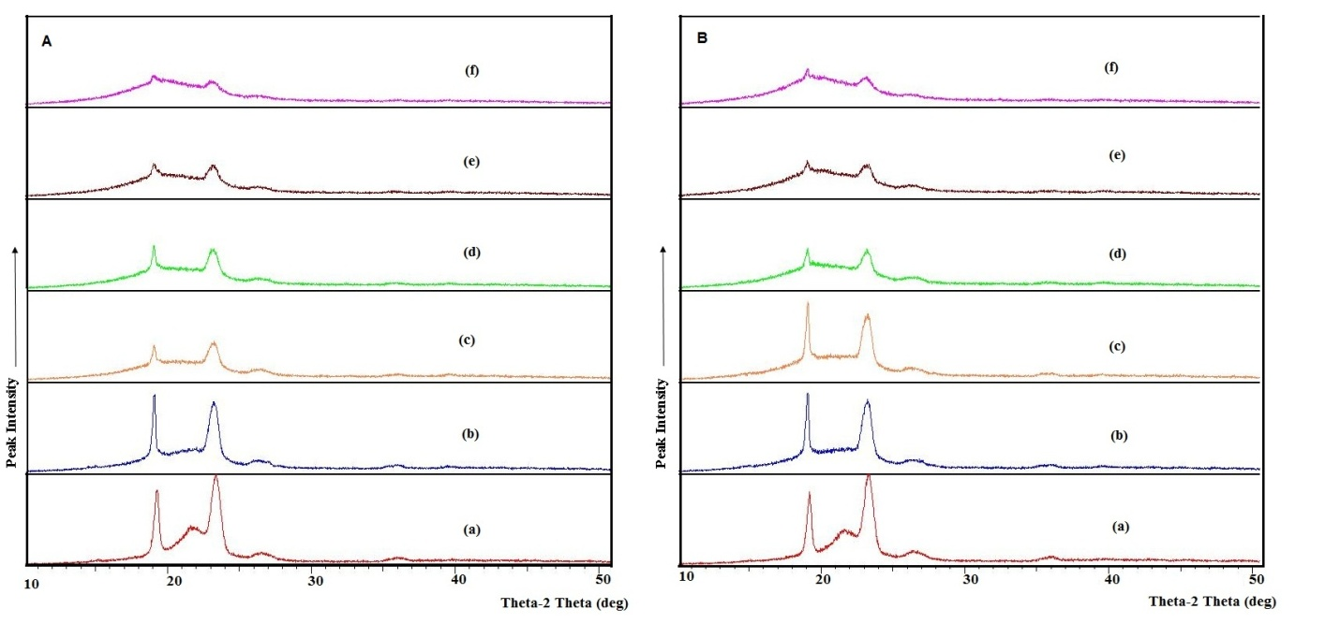
Figure 1 Powder-XRD patterns of solid system containing (A) Captex 355:Acconon C-50 and (B) Captex 355:Gelucire 50/13. Key: (a) 100% Stearoyl polyoxylglyceride; (b) Captex 355/ stearoyl polyoxylglyceride, 3:7; (c) Captex 355/stearoyl polyoxylglyceride, 4:6; (d) Captex 355/ stearoyl polyoxylglyceride, 1:1; (e) Captex 355/stearoyl polyoxylglyceride, 6:4; and (f) Captex 355: stearoyl polyoxylglyceride 7:3

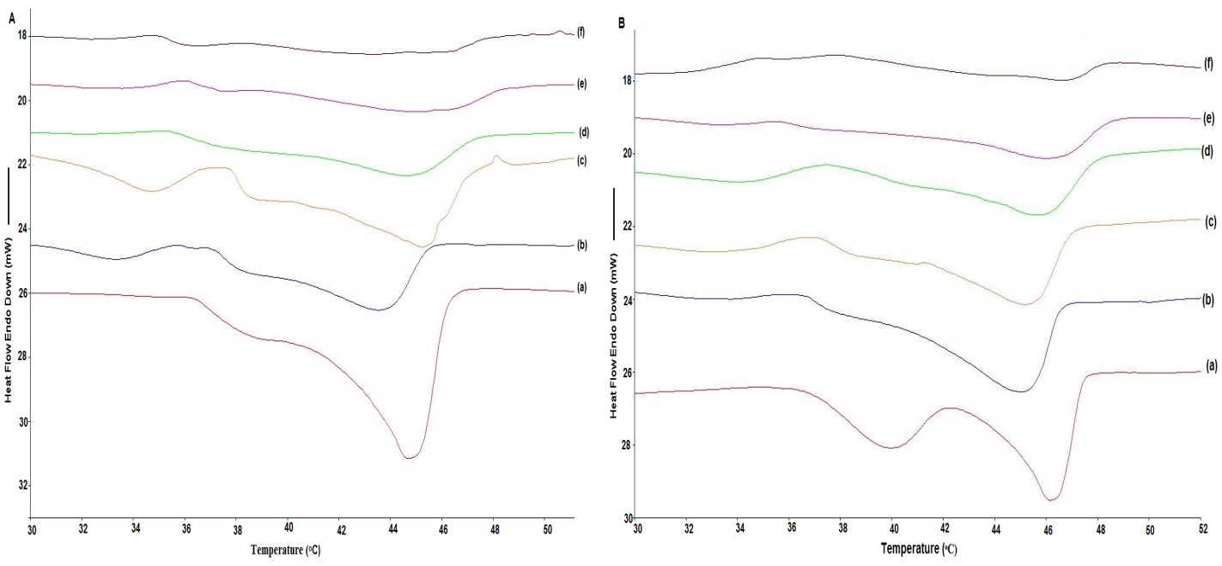
Figure 2 DSC scans of solid system containing (A) Captex 355/Acconon C-50 and (B) Captex 355/Gelucire 50/13. Key: (a) Neat stearoyl polyoxylglyceride (Acconon C-50 or Gelucire 50/13); (b) Captex 355/stearoyl polyoxyl glyceride, 3:7; (c) Captex 355/stearoyl polyoxyl glyceride, 4:6; (d) Captex 355/stearoyl polyoxyl glyceride, 1:1; (e) Captex 355/stearoyl polyoxyl glyceride, 6:4; and (f) Captex 355/stearoyl polyoxyl glyceride, 7:3.

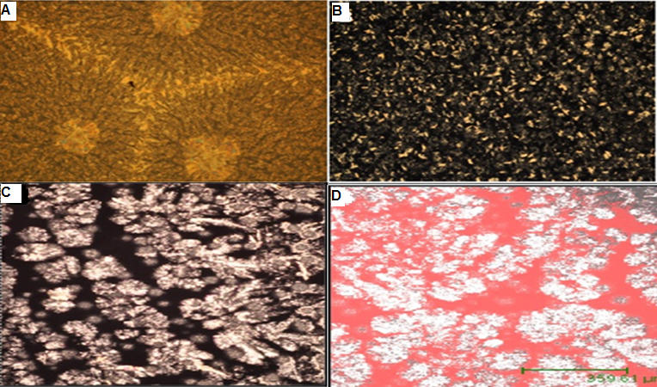
Figure 3 Photomicrographs of solid systems incorporating Captex 355 in stearoyl polyoxylglycerides (Acconon C-50). Key: (A) Photomicrograph of neat stearoyl polyoxylglycerides obtained from cross-polarized optical microscope; (B) photomicrograph under cross-polarized optical microscope of 1:1-Captex 355/stearoyl polyoxylglyceride cooled to room temperature by rapid cooling; (C) photomicrograph under cross-polarized optical microscope of 1:1-Captex 355/stearoyl polyoxylglyceride cooled to room temperature at controlled rate of 0.1 ºC/min over period of 4 hours; (D) confocal fluorescence photomicrograph of 1:1-Captex 355/stearoyl polyoxylglyceride (1:1) cooled to room temperature at controlled rate of 0.1 ºC/min over period of 4 hours.

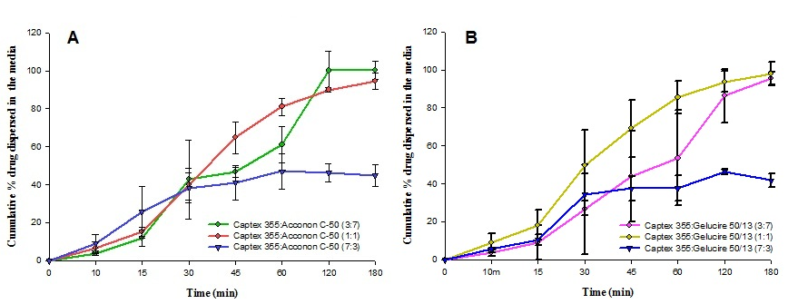
Figure 4 Dispersion profile of solid system containing (A) Captex 355/Acconon C-50 and (B) Captex 355/Gelucire 50/13 using 250mL 0.01N HCL as dispersion medium at 37 ºC.

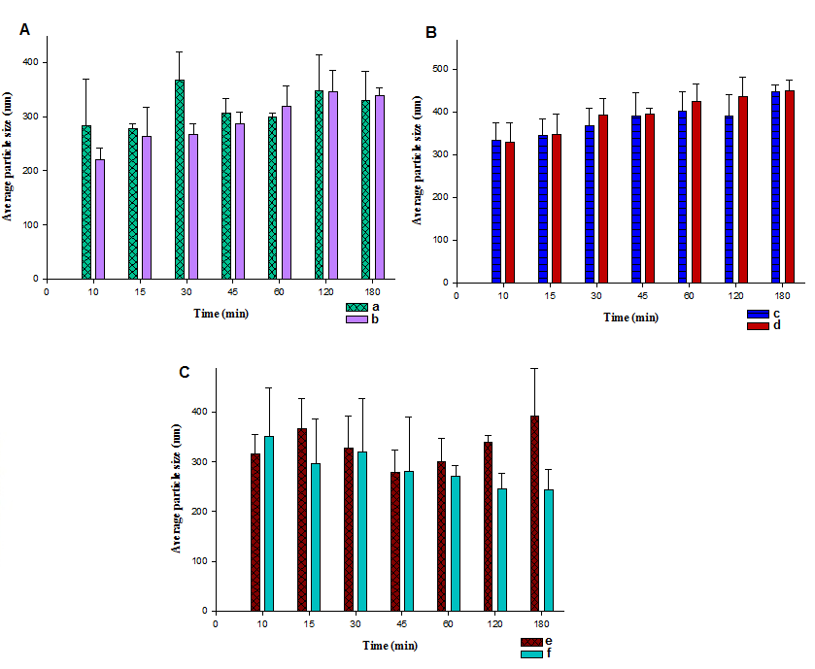
Figure 5 Average particle size of emulsion of solid preconcentrate in aqueous media during dispersion test. Key: (a) 3:7-Captex 355/Acconon C-50 without drug; (b) 3:7-Captex 355/Acconon C-50 with drug; (c) 1:1-Captex 355/Acconon C-50 without drug; (d) 1:1-Captex 355/Acconon C-50 with drug; (e) 7:3-Captex 355/Acconon C-50 without drug; and (f) 7:3-Captex 355/Acconon C-50 with drug.

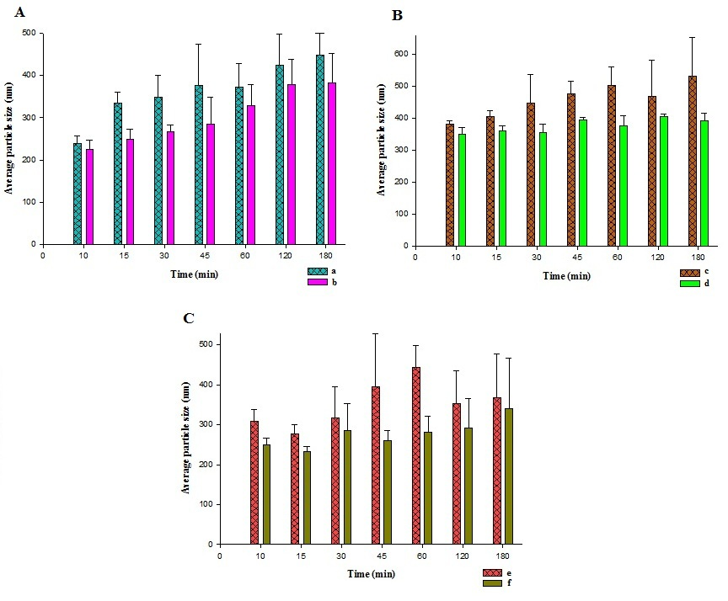
Figure 6 Average particle size of emulsion of solid preconcentrate in aqueous media during dispersion test. Key: (a) 3:7-Captex 355/Gelucire 50/13 without drug; (b) 3:7-Captex 355/ Gelucire 50/13 with drug; (c) 1:1-Captex 355/ Gelucire 50/13 without drug; (d) 1:1-Captex 355/ Gelucire 50/13 with drug; (e) 7:3-Captex 355/ Gelucire 50/13 without drug; and (f) 7:3-Captex 355/ Gelucire 50/13 with drug.

