Figure Captions
Figure 1.Microphotograph depicting SEM Chirauli nut tree gum at X3000 magnification
Figure 2. Microphotograph depicting SEM of batch M4 (20:15:65), E (20:2:15:63)
Figure 3. In Vitro Dissolution Profile of Capsules Containing Pellets Prepared With Chirauli Nut Tree Gum, Mcc pH101
Figure 4. In Vitro Dissolution Profile of Capsules Containing Pellets Prepared With MCC-Sodium CMC-Drug-Ethyl Cellulose (Batch E)
Figure 5. In Vitro Dissolution Profile of Capsules Containing Marketed Formulation
Figure 6. Comparative in-vitro study of spheroids
Figure 7. Peppa’s Plot for Batch M4 (20:15:65)
Figure 8.Peppa’s Plot for Batch E (20:2:15:63)

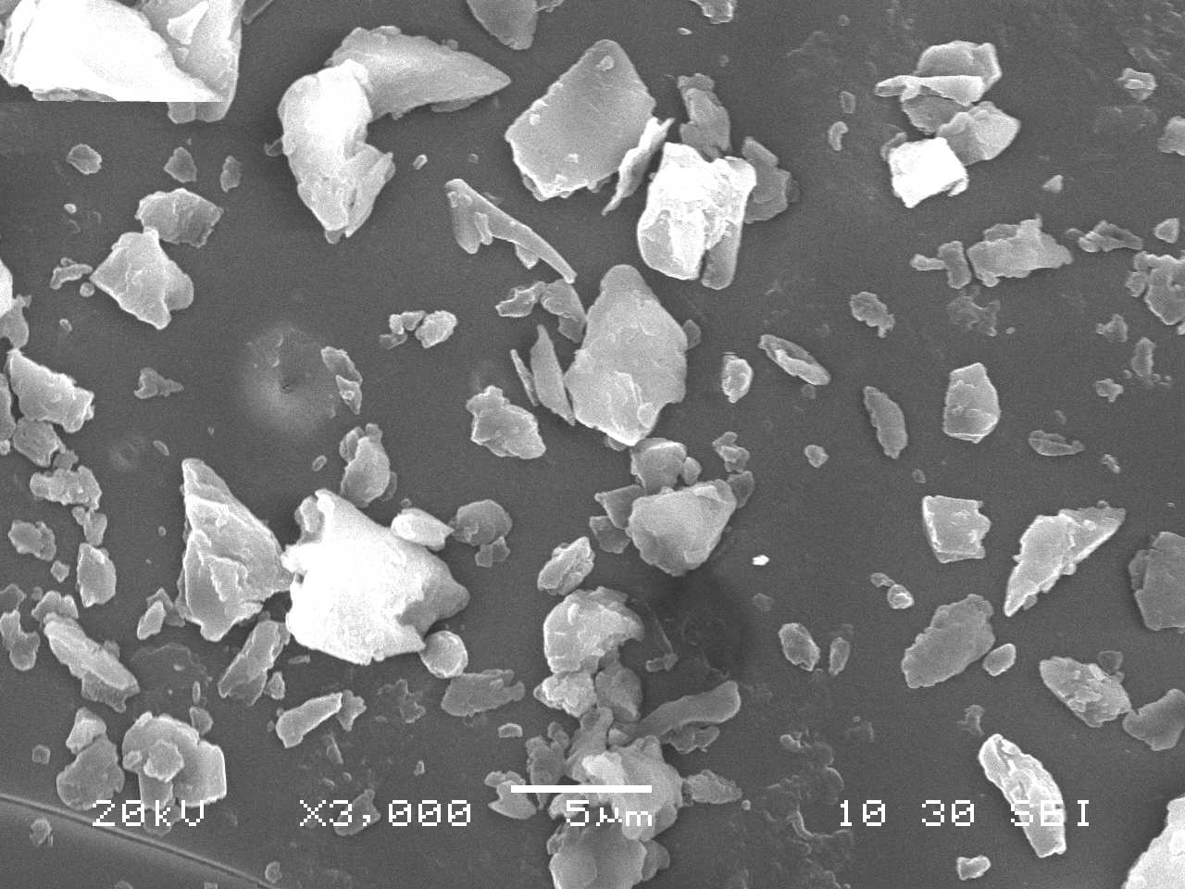
Figure 1.Microphotograph depicting SEM Chirauli nut tree gum at X3000 magnification

Batch M4 (20:15:65) Batch E (20:2:15:63)
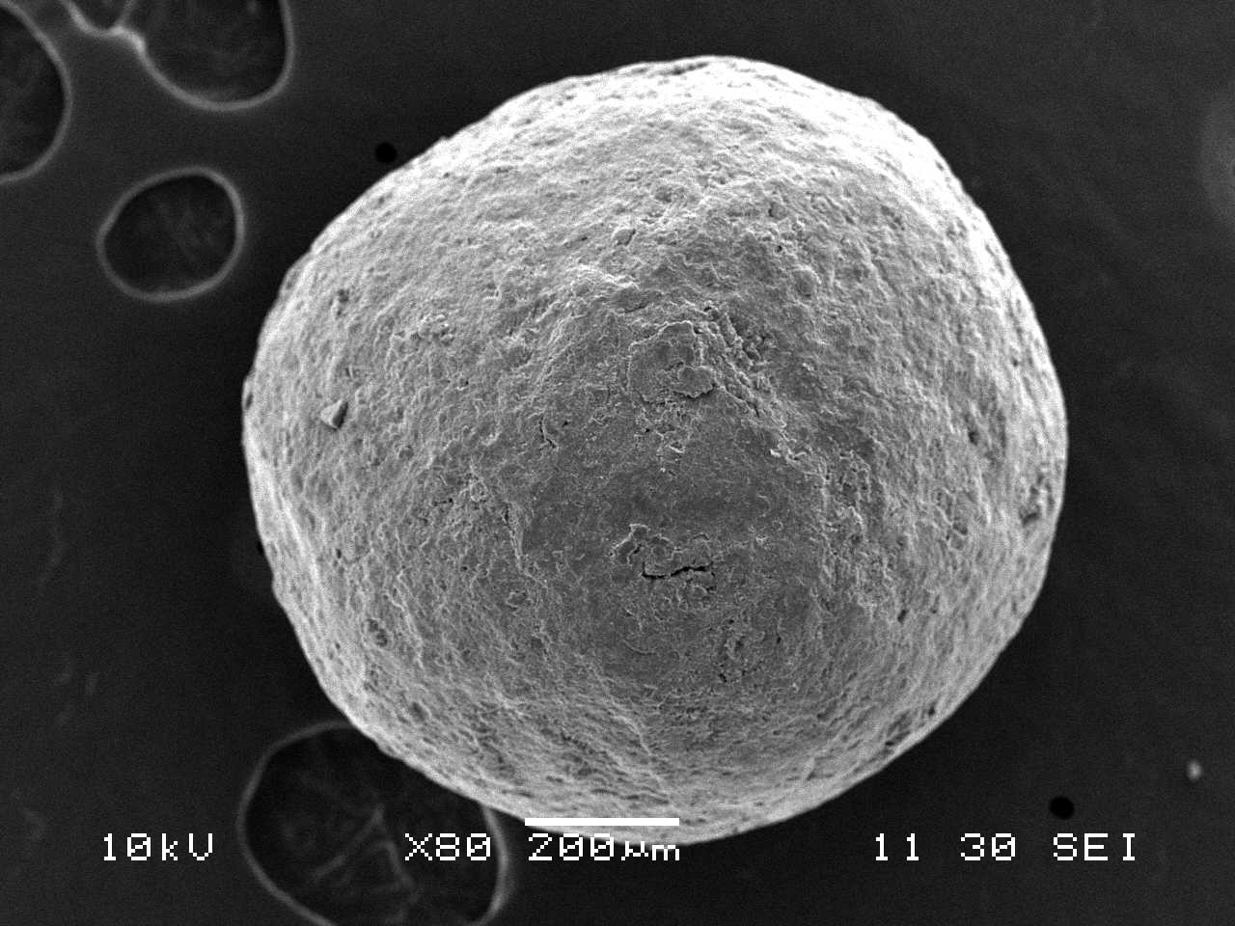
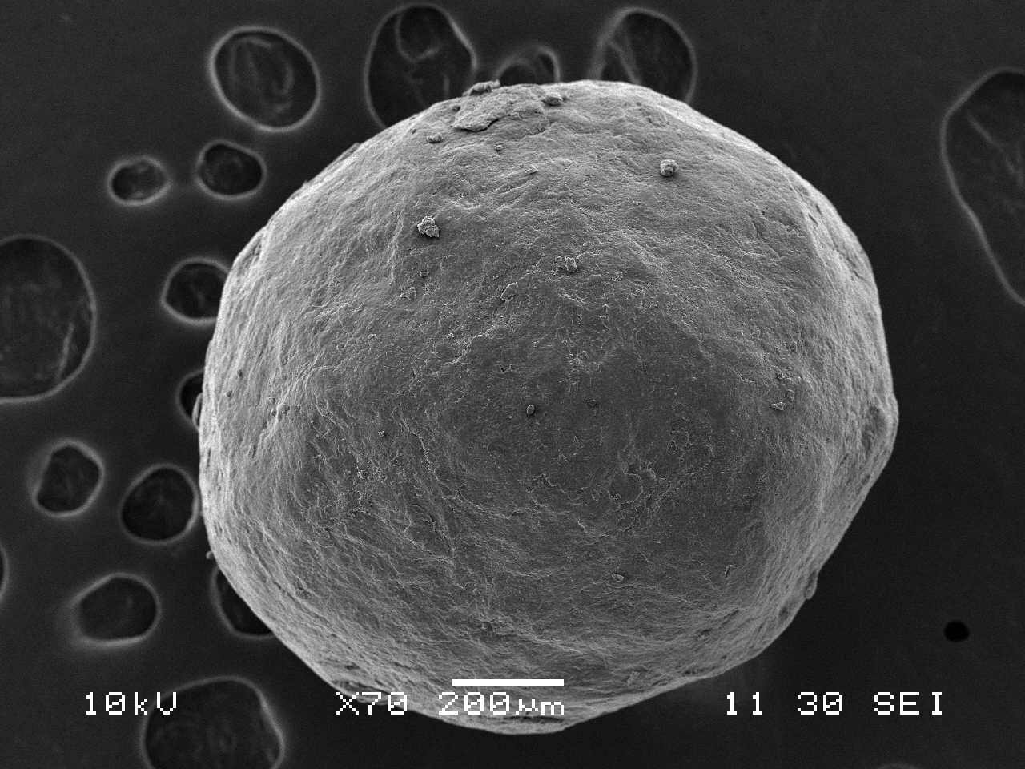

FIGURE 3

Figure 2. Microphotograph depicting SEM of batch M4 (20:15:65), E (20:2:15:63)

Figure 3. In Vitro Dissolution Profile of Capsules Containing Pellets Prepared With Chirauli Nut Tree Gum, Mcc pH101

Figure 4. In Vitro Dissolution Profile of Capsules Containing Pellets Prepared With MCC-Sodium CMC-Drug-Ethyl Cellulose (Batch E)

Figure 5. In Vitro Dissolution Profile of Capsules Containing Marketed Formulation

Figure 6. Comparative in-vitro study of spheroids

Figure7. Peppa’s Plot for Batch M4 (20:15:65)

Figure.8 Peppa’s Plot for Batch E (20:2:15:63)

