Metadata
The novelty of this research paper is selection of potential formulations based on mechanical evaluation by instron (Tensile strength, modulus of elasticity), physiochemical properties as well as
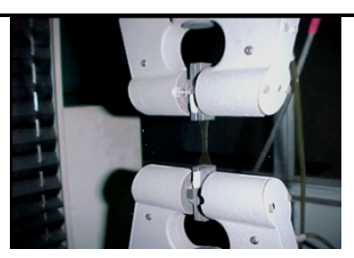
Instron Material Testing Machine with specimen to be tested in the pneumatic grip
different chemical enhancers like l-menthol, oleic acid and phospholipon80 were added to compare the release pattern of the drug. of matrix patches. Many studies have employed phospholipids as vesicles (liposomes) to carry drugs into and through human skin. However, none of the studies have used phospholipids in a non-vesicular form as penetration enhancers. This is the first time this enhancer is incorporated in to the matrix system. And also got a excellent drug permeation with this enhancers compare to conventional excipients
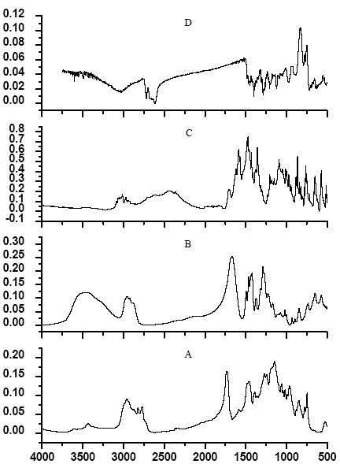
From the ATR FTIR studies, the polymer, copolymer and the drug CPM film directly analyzed and do not have any interaction among the excipients.

ATR FTIR Graphs: A: Eudragit E100; B: PVP; C: CPM;
D: E 100:PVP:CPM matrix patch.

