Figure 1: Cracks on the delayed release film of hygroscopic tablet cores
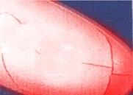

Figure 2: Film cracking during coating
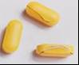

Figure 3: Factors affecting the film of coated tablets towards cracks

